
CHICKEN CURRY
CAULI & CHICKEPEA CURRY
STEAMED RICE
MINI NAAN BREAD (G)
MIXED VEG. BROCCOLI
SHORTBREAD BISCUIT (G)
BREADED CHICKEN STEAK (G)
QUORN CHIQUIN STEAK (G)
HERBY DICED POTATOES
BAKED BEANS, SWEETCORN

MINI MUFFIN (G.M.E)
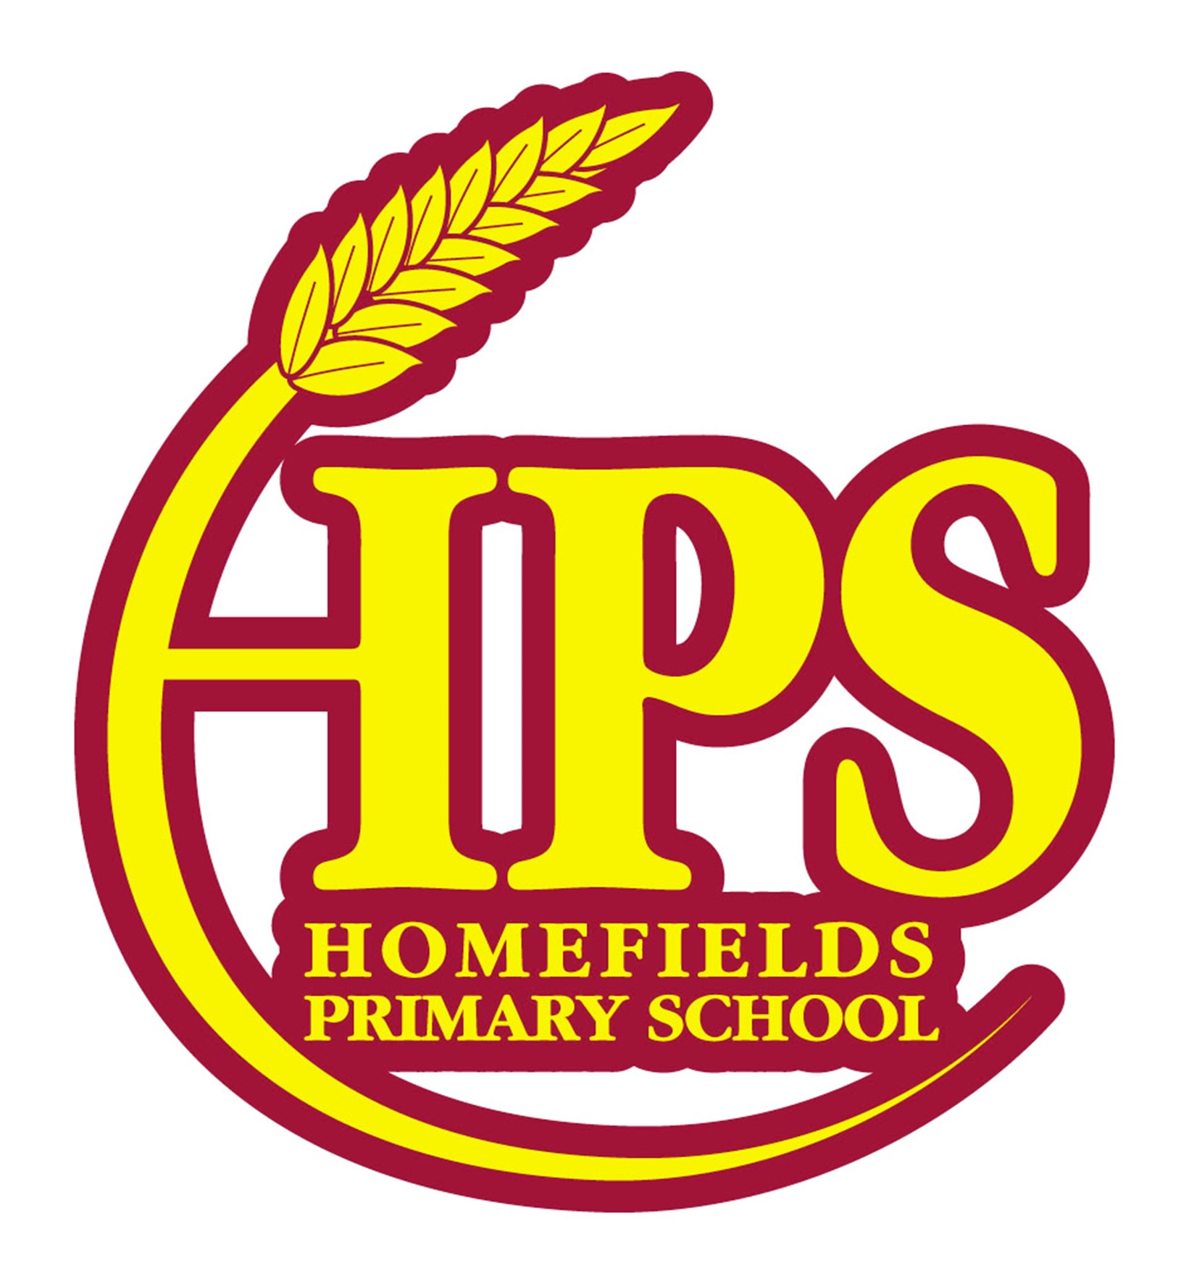
CELERY ©. CRUSTACEANS (CR). EGGS €. FISH (F). GLUTEN (G) LUPIN (L). MILK (M). NUTS (N). MOLLUSCS (MC). PEANUTS (P). SESAME (SE). SOYBEANS (S). SULPHITES (SU) MUSTARD (MU)
WATER, FRESH FRUIT YOGHURT JACKET POTATO AVAILABLE DAILY. MENU SUBJECT TO CHANGE, SPECIAL DIETS CATERED FOR..

HOMEMADE STEAK PIE (G)
CHEESE & ONION ROLL (G.M)
MASHED POTATO
CARROTS, CAULIFLOWER
GRAVY
RICE KRISPIE CAKE (G.M)

CHICKEN NUGGETS (G)
QUORN DIPPERS (G)
CHIPS
BAKED BEANS. SWEETCORN

CHOCOLATE COOKIE (G)
ROAST CHICKEN FILLET
VEGAN CHICQUIN (G)
ROAST POTATOES
SLICED CARROTS. BROCCOLI
GRAVY
SPRINKLE SPONGE (G.M.E)
FISH FINGER SUB (G.F)
VEGGIE FINGER SUB (G)
POTATO WEDGES
BABY CARROTS. PEAS

JAM TART & CREAM (G.M)

HOLIDAYS

EASTER
APRIL 2026
HOMEFIELDS PRIMARY SCHOOL
BIG BREAKFAST
SAUSAGE (G) BACON
VEGAN SAUSAGE (G)
HASH BROWN. BAKED BEANS
CHOPPED TOMATOES

CHOCOLATE CRUNCH (G.E)
PEPPERONI PASTA BAKE (G.M)
TOMATO PASTA (G)
GARLIC SLICE
PEAS. BABY CARROTS

JELLY
BAKED JACKET POTATO
GRATED CHEESE (M) TUNA (F)
BAKED BEANS
SWEETCORN

ICE CREAM TUB (M)

SAUSAGE ROLL (G)
CHEESE & ONION ROLL (G)
MASHED POTATO.GRAVY
PEAS. CAULIFLOWER

JELLY
FISH STARS (G.F)
QUORN DIPPERS (G)
CHIPS
MUSHY PEAS, SWEETCORN

ICE CREAM TUB (M)
PORK MEATBALLS (G)
QUORN MEATBALLS (G)
PENNE PASTA (G) TOMATO SAUCE
GARDEN PEAS, CARROTS
ICED LEMON SPONGE (G.M.E)
CHEESE & TOMATO PIZZA (G,M)
SALMON FISHCAKE (G.F)
POTATO WEDGES
SWEETCORN
COLESLAW (M.MU)
BAKED DOUGHNUT (G.M.E)
CHICKEN FAJITAS (G)
QUORN FAJITAS (G)
RICE
SIDE SALAD. SWEETCORN

VANILLA CHEESECAKE (G.M)

