
Can you write your name here?

(Parents please write name next to child’s attempt)
Draw a picture of your family here.

What do you enjoy doing?

My name is…
I like to…
This is my family…
Please return this form on your transition visit on Wednesday 25th June
All About me…

Draw some things that you are good at.
Things that worry me…

Is there anything you do not like?
Things I am good at…

My favourite things

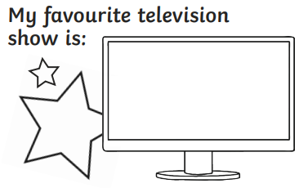
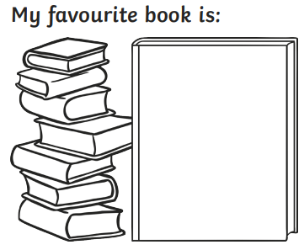
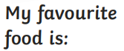



About my child (voice of the parent/s)
Friendships and social interactions
How do they typically interact with peers (e.g., sharing, turn-taking, joining in play)?

Are there any difficulties you've noticed in social settings?

Emotional Regulation:
How does your child typically express emotions such as excitement, frustration, or disappointment?

How do they respond to changes in routine or unexpected events or settling into new places?

Listening, Attention and Understanding
Can your child concentrate on a task or activity for a short period?

Do they follow spoken instructions and understand simple questions?
Rules and Boundaries
How well does your child cope with rules and boundaries?
Can they follow simple multi-step instructions?

Family
Please tell us a little about your child’s home life. Who lives with them? Are there siblings, pets, or extended family involved in their daily life?

Are there any cultural, religious, or personal values you’d like us to be aware of?

What languages does your child speak/ understand?
(voice of the parent continued…)
Questions/ worries
Do you have any questions or worries?
Self-care and Toileting
Skill | Always | Sometimes | Not Yet | Comments
Fully toilet trained during the day | ☐ | ☐ | ☐
Independently uses toilet (wipe own bottom) | ☐ | ☐ | ☐
Washes and dries hands independently | ☐ | ☐ | ☐
Blows/wipes nose independently | ☐ | ☐ | ☐
Dresses and undresses with minimal support  (puts on and fastens coat/ puts own shoes on) | ☐ | ☐ | ☐
Uses cutlery effectively | ☐ | ☐ | ☐

