Everyday Materials KS1 Autumn 1
Science Vocabulary
Hard | 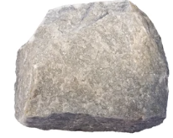 | A material that is not easily broken. A material that is firm. | Transparent | 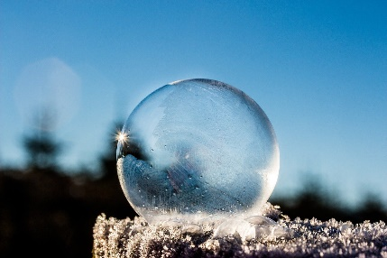 | A material that your able to see through.
Soft |  | A material that is delicate and the shape is easy to change. | Opaque | 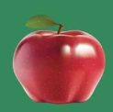 | A material that you cannot see through.
Shiny | 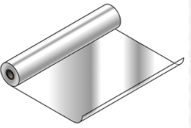 | A material that is glossy and easy to reflect. | Waterproof |  | A material that rain doesn’t seep through.
Dull | 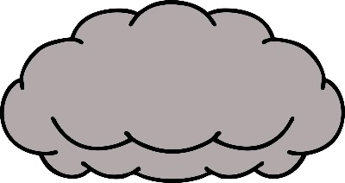 | A material that is dark. | Absorbent | 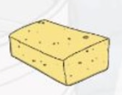 | A material that soaks in the water.
Stretchy | 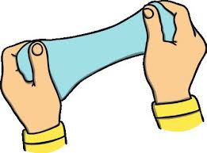 | A material that is easy to pull and the shape is easy to change. | Sharp |  | Having an edge or point that is able to cut or pierce something.
Rough | 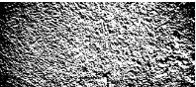 | A material that is bumpy. | Stiff |  | Not easily bent or changed in shape.
Smooth | 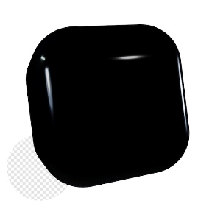 | A material that is even and flat. | Wood | 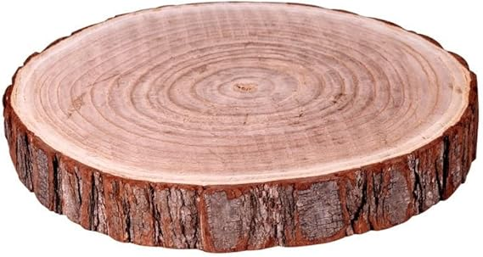 | A hard material that is strong.
Bendy | 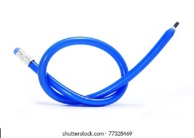 | A material that is easy to bend and the material can change shape. | Plastic | 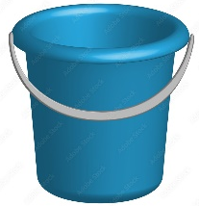 | A material that can be easily shapes and moulded.
Metal | 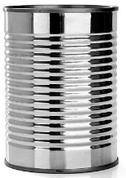 | A material that is hard and shiny. | Glass | 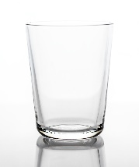 | A see-through material that can be moulded when heat is applied.
Rock |  | A material that is hard. | Paper | 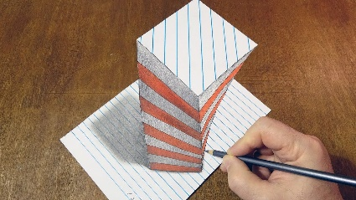 | A thin material made from trees.
Cardboard | 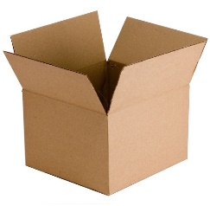 | Stiff paper which is really thick, | Rubber | 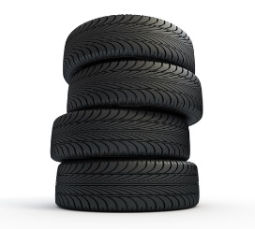 | An elastic material made from latex.

