
History
To investigate and interpret the past
- Observe or handle evidence to ask questions and find answers to questions about the past.
- Ask questions such as: What was it like for people? What happened? How long ago?
- Use artefacts, pictures, stories, online sources and databases to find out about the past.
To build an overview of world history
- Describe historical events
To understand chronology
- Place events and artefacts in order on a time line.
- Label time lines with words or phrases such as: past, present, older and newer.
To communicate historically
Use words and phrases such as; a long time ago, recently, when my parents/carers were children, years, decades and centuries to describe the passing of time.
Art

To develop ideas
- Respond to ideas and starting points.
- Explore different methods and materials as ideas develop.
To master techniques
- Draw lines of different sizes and thickness.
- Colour neatly following the lines.
Painting
- Use thick and thin brushes
- Mix primary colours to make secondary
- Add white to colours to make tints and black to colours to make tones
- Create colour wheels
Collage
- Use a combination of materials that are cut, torn and glued.
- Sort and arrange materials.
- Mix materials to create texture.
Digital Media
- Use a wide range of tools to create different textures, lines, tones, colours and shapes.
To take inspiration from the greats (classic and modern)
- Describe the work of notable artists, artisans and designers.
- Use some of the ideas of artists studied to create pieces.

The Circus is Coming to Town
Coverage Grid
KS1 – Autumn 1

This topic allows us to step into a world of a colour, as we learn all about primary and secondary colours as well as the artist Kandinsky. We will be learning about the Circus, finding out where it began, different circus acts and creating our very own chariots. Using maps and atlases the children will investigate where the Circus travels to naming countries and oceans. There’s lots of fun to be had at the Circus, so come along and join in!
RE
Who is a Muslim and what do they believe?
- Talk about some simple ideas about Muslim beliefs about God, making links with some of the 99 Names of Allah.
- Re-tell a story about the life of the Prophet Muhammad.
- Recognise some objects used by Muslims and suggest why they are important.
- Identify some ways Muslims mark Ramadan and celebrate Eid-ul-Fitr and how this might make them feel.

History
- Observe or handle evidence to ask questions and find answers to questions about the past.
- Ask questions such as: What was it like for people? What happened? How long ago? Use artefacts, pictures, stories, online sources and databases to find out about the past.
- Identify some of the different ways the past has been represented.
- To know how/when/where the circus began.
- To know what life at the circus was like.
- To know and discuss the changes that have taken place in the history of the circus e.g. animals Vs no animals To know and talk about the timeline of the history of the circus. Enquiry Question- P4C- Should animals be used in the circus? Explore reasoning- think about interpretations.

PE- Dance
- Copy and remember moves and positions
- Move with careful control and coordination.
- Link two or more actions to perform a sequence.
- Choose movements to communicate a mood, feeling or idea.

Theory and Evaluation
- To understand that our hearts beat faster when we exercise.
- To watch the performance of a peer and comment on the positives and areas for improvement.
- To use ICT to evaluate performances making relevant comments about positives and areas for improvement.

PSHE- Families and Relationships
- Understanding that different people can be in a family and that families look after us.
- Develop an understanding of the characteristics and importance of good, positive friendships.
- Learn how other people show their feelings, that people can feel differently to them, and how to show others that they care.
- Understand how friendships can make us feel and the skills needed to work with other people.
- Develop their understanding that friendships can have problems but that these can be overcome.
- Understanding about change and loss and how this can affect us.

Computing
To communicate
- Use a range of applications and devices in order to create digital content that communicates ideas, work and messages

Online Safety- Privacy and Security
Year 1
- I can explain that passwords are used to protect information, accounts and devices.
- I can recognise more detailed examples of information that is personal to someone. (eg where someone lives and goes to school, family names.)
- I can explain why it is important to always ask a trusted adult before sharing any personal information online, belonging to myself or others.
Year 2
- I can explain how passwords can be used to protect information, accounts and devices.
- I can explain and give examples of what is meant by ‘private’ and ‘keeping things private’.
- I can describe and explain some rules for keeping personal information private (e.g. creating and protecting passwords).
- I can explain how some people may have devices in their homes connected to the internet and give examples (e.g. lights, fridges, toys, televisions)

Science- Use of everyday materials
Year 1
- Distinguish between an object and the material from which it is made;

- Identify and name a variety of everyday materials, including wood, plastic, glass, metal, water, and rock;
- describe the simple physical properties of a variety of everyday materials;

- Compare and group together a variety of everyday materials on the basis of their simple physical properties.

Year 2
- Identify and compare the suitability of a variety of everyday materials, including wood, metal, plastic, glass, brick, rock, paper and cardboard for particular uses;

- Find out how the shapes of solid objects made from some materials can be changed by squashing, bending, twisting and stretching.

Music
To Perform
- Take part in singing, accurately following the melody.
- Follow instructions on how and when to sing or play an instrument.

To Transcribe
- Use symbols to represent a composition and use them to help with a performance.

Maths
Number and Place Value

Year 1
• Count to and across 20, forwards and backwards, beginning with 0 or 1, or from any given number
• Count, read and write numbers to 20 in numerals; count in multiples of twos, fives and tens
• Given a number, identify one more and one less
• Use the language of: equal to, more than, less than (fewer), most, least
• Identify and represent numbers using objects and pictorial representations including the number line.
• Read and write numbers from 1 to 20 in numerals and words.

Year 2
• Count to and across 50, forwards and backwards, beginning with 0 or 1, or from any given number
• Count, read and write numbers to 50 in numerals.
• Count in multiples of twos, fives and tens
• Recognise the place value of each digit in a two-digit number (tens, ones)
• Identify, represent and estimate numbers using different representations, including the number line. Compare and order numbers from 0 up to 50; use and = signs
• Read and write numbers to at least 50 in numerals and in words.
Addition and Subtraction

Year 1
• Read, write and interpret mathematical statements involving addition (+), subtraction (–) and equals (=) signs
• Represent and use number bonds and related subtraction facts within 20
• Add and subtract one-digit and two-digit numbers to 20, including zero.

Year 2
• Solve problems with addition and subtraction using column method.
• Recall and use addition and subtraction facts to 20 fluently, and derive and use related facts up to 100.

English- Year 2 Objectives
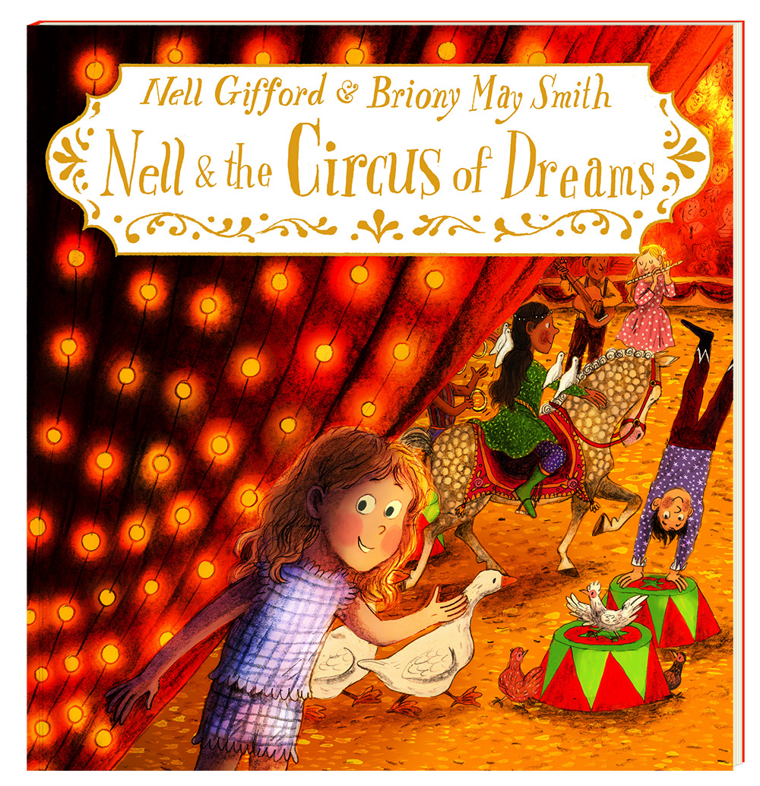
Spoken Language
• use spoken language to develop understanding through speculating, hypothesising, imagining and exploring ideas
Writing – Spelling
• I can segment spoken words into phonemes (sounds) and represent these by graphemes (letters), spelling many correctly.
Handwriting and Presentation
• I can form lower-case letters of the correct size relative to one another.
• I can use spaces between words that reflects the size of the letters.

Composition
• I can plan or say out loud what I’m going to write about.
• I can write down ideas and/or key words, including new vocabulary.
• I can encapsulate what I want to say, sentence by sentence.
• I can reread to check my writing makes sense.
Vocab, Grammar and Punctuation
• I can use expanded noun phrases to describe and specify. e.g. the small, dazzling fairy.
English- Year 1 Objectives
Spoken Language
- use spoken language to develop understanding through speculating, hypothesising, imagining and exploring ideas Writing
Spelling
- I can use words containing each of the 40+ phonemes already taught.
- I can name the letters of the alphabet in order.
Handwriting and Presentation
- I can sit correctly at a table, holding a pencil comfortably and correctly.
- I can begin to form lower-case letters in the correct direction, starting and finishing in the right place.
Composition

• I can say out loud what I’m going to write about.
• I can compose a sentence orally before writing it.
• I can re-read what I’ve written to check it makes sense.

Vocab, Grammar and Punctuation

• I can leave spaces between words.
• I can begin to punctuate sentences using a capital letter and a full stop.

