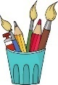
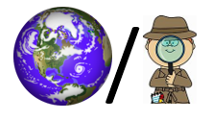
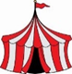
Homefields Primary School
The Circus Comes to Town Vocabulary-KS1 Autumn 1
Circus | A group of acrobats, clowns and other entertainers who travel around and perform for people, usually in a large tent. | 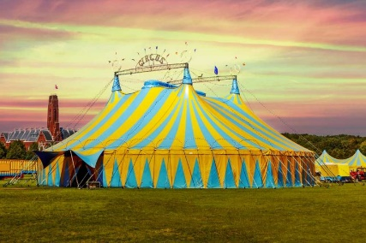 | Primary Colours | Red, Yellow and Blue | 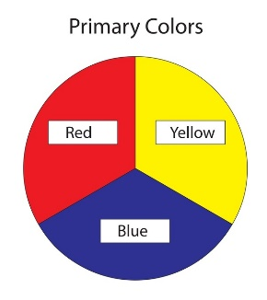
Circus Maximus | An ancient Roman chariot-racing stadium and entertainment venue in Rome, Italy. | 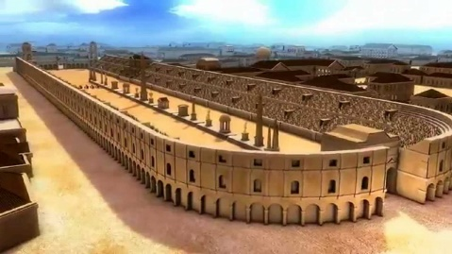 | Secondary Colours | A colour which has been made by mixing two primary colours together. | 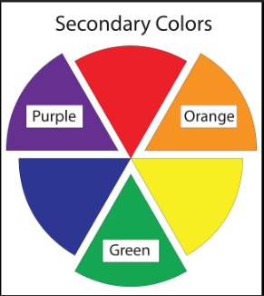
Chariot | A vehicle pulled by horses. | 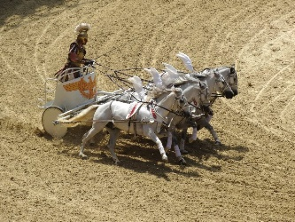 | Tint | A lighter colour made by adding white. | 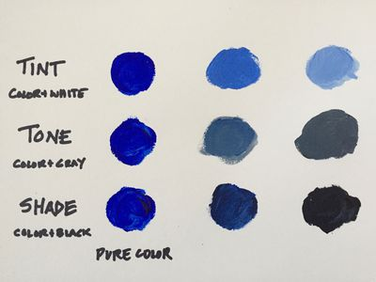
Hippodrome | The London Hippodrome was the first theatre designed for circus and variety performances. | 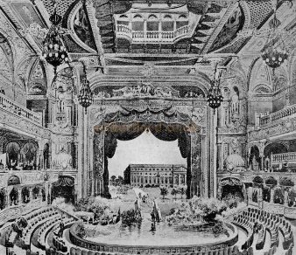 | Shade | A darker colour made by adding black.
Wassily Kandinksy | A famous artist. | 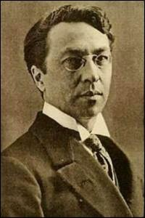 | Concentric Circles | A Kandinsky piece of art created in 1913 | 

