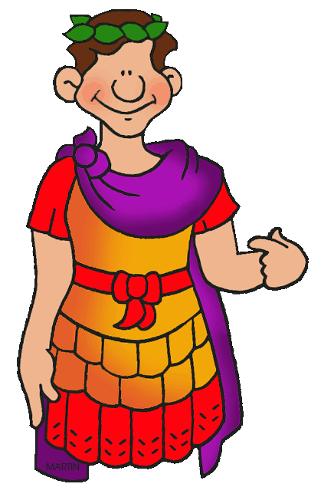

R I K O
W   R  B? 55BC- 410AD

I P
E C | F R     B.
J C | F R      B.
B | S       R (C ).

K T | D
AD | A D – T      J C.
BC | B C. T      J C.
Celtic Tribes | T  (C)    B   I . T     E.
Century (Army) | A    R     80      
Conquer | T       .
Emperor | A     .
Empire | A         .
Iceni Tribe | A C    B      R.
Invasion | O       .
Legion | O    R ;  4,000  6,000  .
Rebellion | A C    B      R.

Key Events
55BC | F   B   J C,     .
43AD | E C      B.
60AD | T  ! T   B  R .
410AD | R  B    I.

Why the Romans were so important to Britain
Language | L,   R ,        .
Roads | R    B      .
Buildings | P , ,       B.
Names | W  R    (J, J)   (M, J).
W   ?
B | T  B: F  F B  R
B | B: H H – T R R
W | ://../z//z8 (BBC W)

T R E  117AD
T      R E         .
S        2000  . C           ?


