


Dear parents,
We will soon be starting forest school. This will either be on a Monday or a Wednesday, depending on the weather and staffing. We can only take out groups of 10 at a time, meaning every child will have a turn at some point over the year. We cannot give exact dates for each group as we are very dependent on the weather and staffing. Each group will have either 5 or 6 sessions at forest school, depending on term length. This means that in the summer term, all children should get another turn outside. We provide special waterproof suits to go over the children’s clothes and we have a range of wellington boots. However, if you would like your child to wear their own boots, please bring these in a named bag and ensure they have their name written inside each boot. For the winter session, we advise that the children wear lots of layers, but we will tell you more about this, if your child is in this group. We will let you know by letter, when your child’s group will be starting nearer the time.

Your child is in Group ____
This should take place approximately during _______________

On the final session of each group, we invite the parents to come and spend time with their child, experience forest school first hand and find out what we have been learning. We apologise that we cannot give dates at this point but as you can appreciate, we are weather dependent. We will give you approximate dates when we inform you of your child’s start dates.

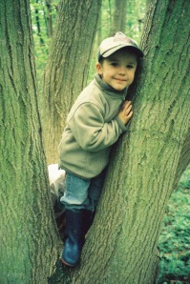
What is Forest School?
Forest School is an amazing opportunity for children to explore the outdoors and provides them with a hands-on learning experience, in a woodland or natural environment. Children build confidence and independence, empathy for others and nature, as well as improving their mental and physical health. They are exposed to manageable risks, developing their understanding of safety, whilst enhancing their self-esteem and responsibility. We are lucky enough to be able to do this on site with a trained Forest School leader.
The children are free to learn outdoor skills, such as climbing, digging, planting, exploring nature and habitats to name but a few.
We have found over the past few years that both the children and parents have really enjoyed this memorable experience. If you would like any more information please see Mrs Werbowy, who is our Forest School expert!

Thank you
The Early Years Team

