Essential letters and sounds EYFS Phonics Home Learning | 
Phase 3 – Spring 1 Week 6

Please support your child to practise and reinforce the phonemes and graphemes we are learning in school.

This week we have spent some time reviewing and revising all of the sounds we have learnt so far and practised reading texts containing these sounds.
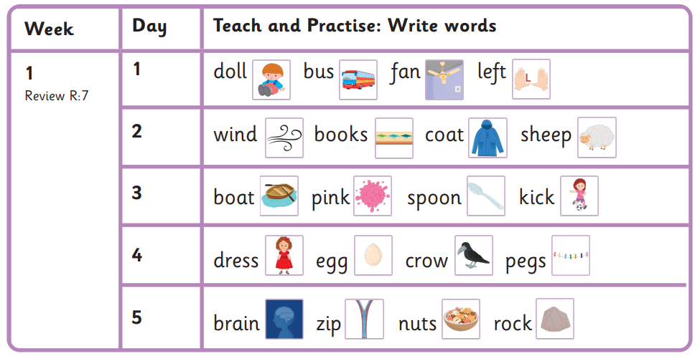
Why not practise reading and writing the words below?

Harder to Read and Spell Words
said, so, have

Essential letters and sounds EYFS Phonics Home Learning
Phase 3 – Spring 2 Week 1

Please support your child to practise and reinforce the phonemes and graphemes we are learning in school.

This half term, we will be continuing to review and revise what we have learnt so far. We will also be reading texts containing the sounds and harder to read and spell words learnt so far.
Why not practise reading and writing the words below?
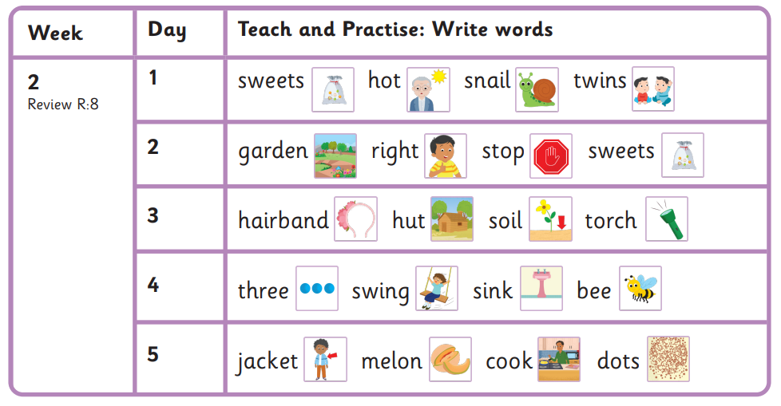

Harder to Read and Spell Words
were, out, like

Essential letters and sounds EYFS Phonics Home Learning
Phase 3 – Spring 2 Week 2

Please support your child to practise and reinforce the phonemes and graphemes we are learning in school.

This half term, we are continuing to review and revise what we have learnt so far. We are reading texts containing the sounds and harder to read and spell words learnt so far.
Why not practise reading and writing the words below?
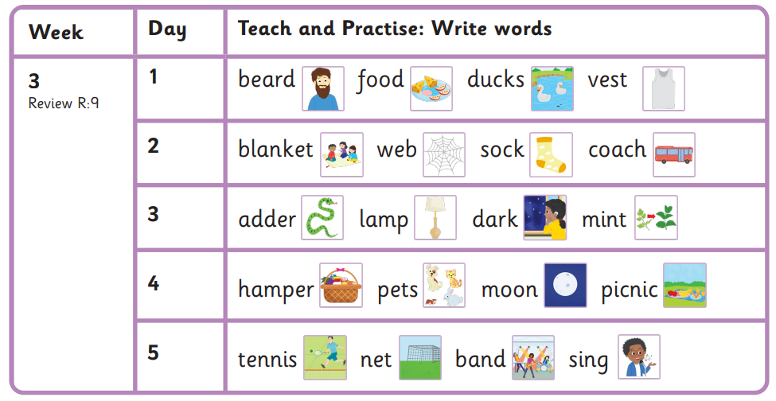

Harder to Read and Spell Words
some, come, there

Essential letters and sounds EYFS Phonics Home Learning
Phase 3 – Spring 2 Week 3

Please support your child to practise and reinforce the phonemes and graphemes we are learning in school.

This half term, we are continuing to review and revise what we have learnt so far. We are reading texts containing the sounds and harder to read and spell words learnt so far.
Why not practise reading and writing the words below?
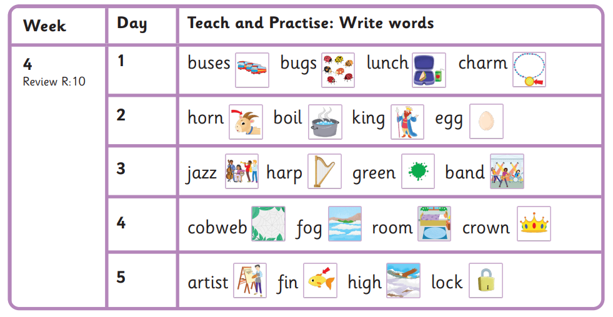

Harder to Read and Spell Words
little, one, do

Essential letters and sounds EYFS Phonics Home Learning
Phase 3 – Spring 2 Week 4

Please support your child to practise and reinforce the phonemes and graphemes we are learning in school.

This half term, we are continuing to review and revise what we have learnt so far. We are reading texts containing the sounds and harder to read and spell words learnt so far.
Why not practise reading and writing the words below?
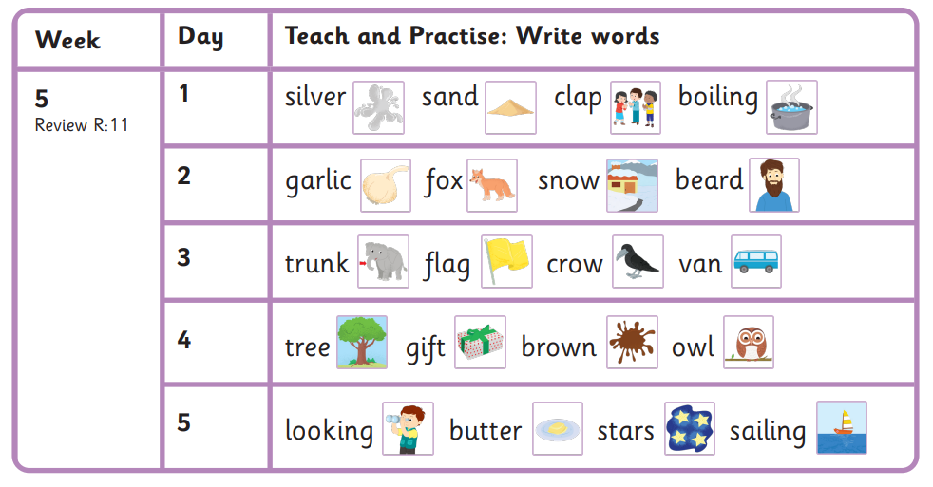

Harder to Read and Spell Words
children, love

Essential letters and sounds EYFS Phonics Home Learning
Phase 3 – Spring 2 Week 5

Please support your child to practise and reinforce the phonemes and graphemes we are learning in school.

This half term, we are continuing to review and revise what we have learnt so far. We are reading texts containing the sounds and harder to read and spell words learnt so far.
Why not practise reading and writing the words below?


