Essential letters and sounds EYFS Phonics Home Learning | 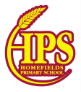
Phase 3 – Autumn 2 Week 7
Please support your child to practise and reinforce the phonemes and graphemes we are learning in school.
This week we have spent some more time reviewing and revising all of the sounds we have learnt so far and practised reading texts containing these sounds.
Why not practise reading and writing the words below?
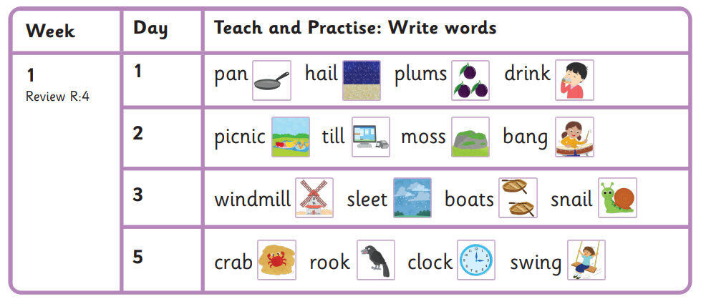

Sounds we have focused on this week | Mnemonics and Rhymes  (to support letter formation and recall) | Words we are learning to segment and blend
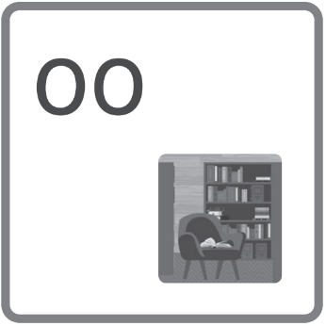 | the book nook | look, nook, book, books, shook, foot, took, crook, rook, wood , cook, soot, good, stood, wooden, looking, booking

Essential letters and sounds EYFS Phonics Home Learning
Phase 3 – Spring 1 Week 1
Please support your child to practise and reinforce the phonemes and graphemes we are learning in school.
Sounds we have focused on this week | Mnemonics and Rhymes  (to support letter formation and recall) | Words we are learning to segment and blend
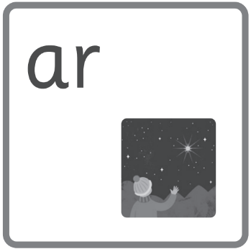 | a far star | car, park, market, jar, farm, far, charm, star, dark, bar, march, harp, sharp, bark, smart, start, spark, artist, garden, harvest, garlic, target
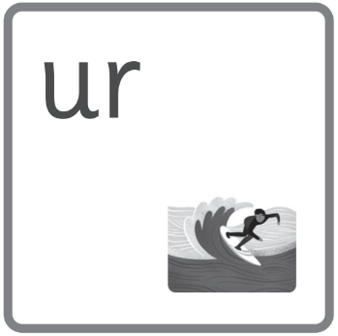 | turn in the surf | surf, turf, burn, hurt, surfing, burning, turn, turning, urn, burst, curl, lurch
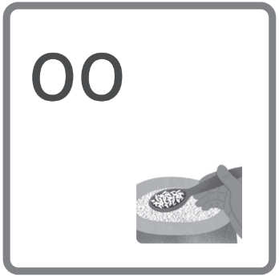 | scoop with a spoon | gloom, peekaboo, spoon, scoop, moon, boot, rooftop, zoo, baboon, troop, cartoon, food, mood, roof, proof
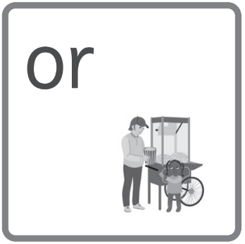 | order some popcorn | fork, storm, corn, morning, sort, born, sweetcorn, popcorn, order, horn, port, sport, porch, torch, torn, cord, ford, form, forbid, inform, transform, transport

Words we are learning to write | Harder to Read and Spell Words
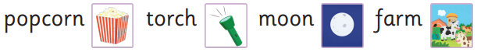 | they, all, are

Essential letters and sounds EYFS Phonics Home Learning
Phase 3 – Spring 1 Week 2
Please support your child to practise and reinforce the phonemes and graphemes we are learning in school.
Sounds we have focused on this week | Mnemonics and Rhymes  (to support letter formation and recall) | Words we are learning to segment and blend
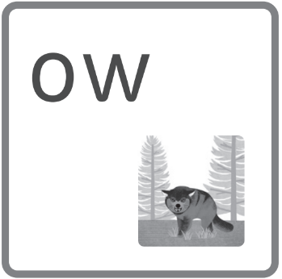 | prowl and growl | cow, owl, down, town, frown, clown, brown, now, crowd, crown, gown, scowl, prowl, growl, howl, brow, scowling, prowling, growling
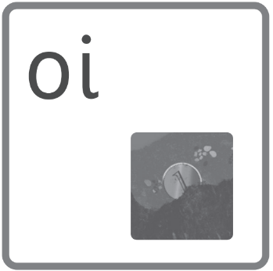 | coin in the soil | spoil, boil, coin, soil, join, boiling, oink, joint, point, ointment, toilet
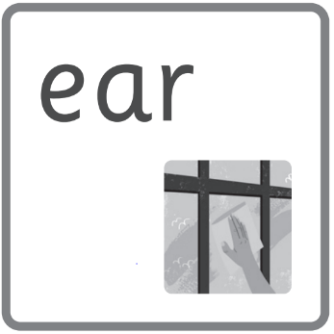 | clear that smear | hear, dear, year, fear, clear, spear, near, gear, ear, tear, hearing, clearing, beard
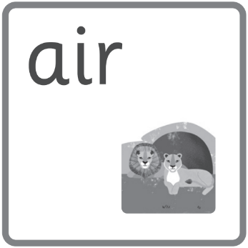 | a pair in the lair | pair, lair, hair, stair, stairs, funfair, chair, hairbrush, airport, flair

Words we are learning to write
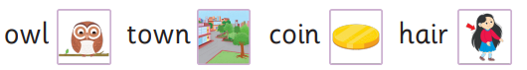

Essential letters and sounds EYFS Phonics Home Learning
Phase 3 – Spring 1 Week 3
Please support your child to practise and reinforce the phonemes and graphemes we are learning in school.
Sounds we have focused on this week | Mnemonics and Rhymes  (to support letter formation and recall) | Words we are learning to segment and blend
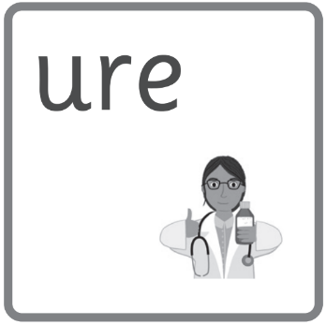 | sure it’s the cure | cure, sure, pure
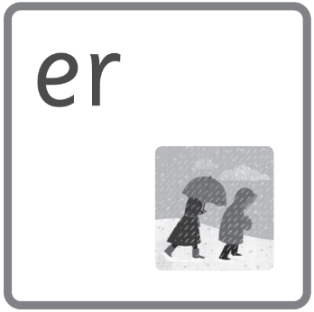 | a bitter winter | sharper, lighter, runner, swimmer, publisher, anger, butter, shutter, fern, bitter, winter, patter, pitter, litter, sprinter
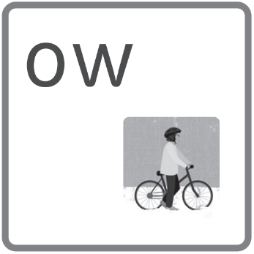 | go slow in the snow | snow, blow, flow, grow, show, growing, slow, elbow, window, row, mow, low, crow

Words we are learning to write | Harder to Read and Spell Words
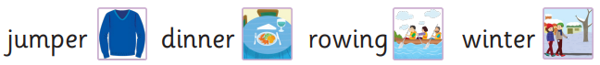 | ball, tall,

Essential letters and sounds EYFS Phonics Home Learning
Phase 3 – Spring 1 Weeks 4 and 5

Please support your child to practise and reinforce the phonemes and graphemes we are learning in school.

This week we have spent some time reviewing and revising all of the sounds we have learnt so far and practised reading texts containing these sounds.
Why not practise reading and writing the words below?
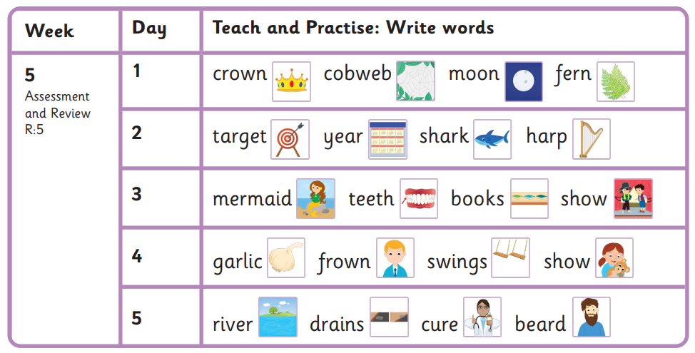
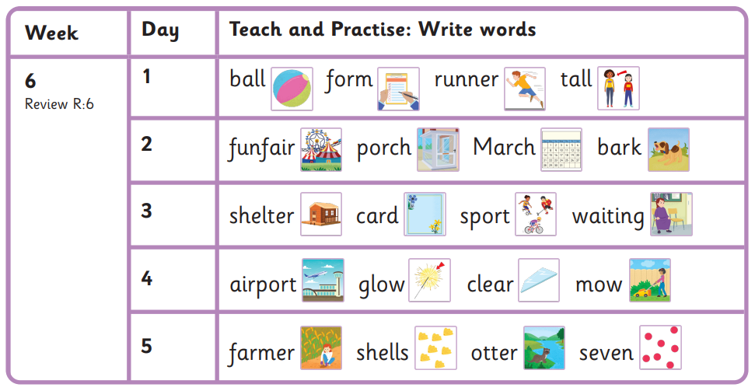
Harder to Read and Spell Words
when, what

