Essential letters and sounds EYFS Phonics Home Learning | 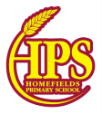
Phase 3 - Autumn 2 Week 1
Please support your child to practise and reinforce the phonemes and graphemes we are learning in school.
Sounds we have focused on this week | Mnemonics and Rhymes  (to support letter formation and recall) | Words we are learning to segment and blend
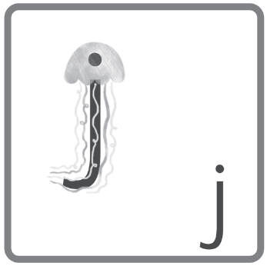 | jellyfish – swoop down the tentacles and dot the body | jam, jog, Jen, jetlag, jet, jacket, just, Jill, Jack
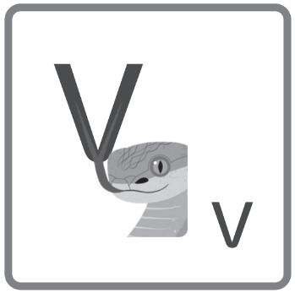 | viper – down the tongue, up the tongue | Vic, vat, van, vet, visit, velvet, Ravi, Kevin
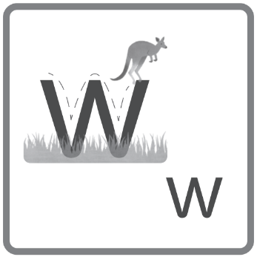 | wallaby – hop to the top, land and hop, land and hop | wig, will, win, web, wag, wig, cobweb, went
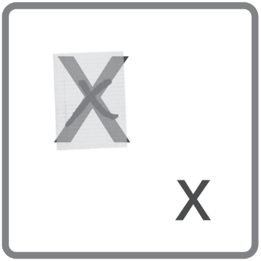 | x x x – criss-cross the kiss | mix, fix, six, exit, wax, mix, tax, vixen, box, flex, fox

Words we are learning to write | Harder to Read and Spell Words
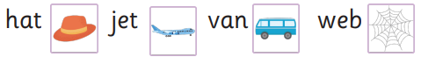 | he, she, buses

Essential letters and sounds EYFS Phonics Home Learning
Phase 3 - Autumn 2 Week 2
Please support your child to practise and reinforce the phonemes and graphemes we are learning in school.
Sounds we have focused on this week | Mnemonics and Rhymes  (to support letter formation and recall) | Words we are learning to segment and blend
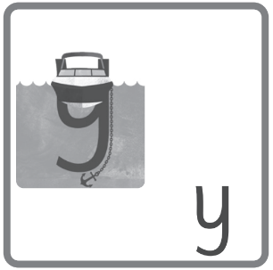 | yacht – under the hull and down to the anchor | yes, yet, yell, yum
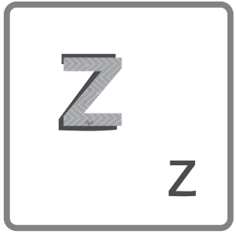  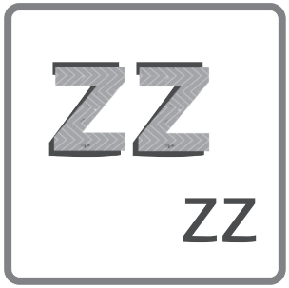 | zigzag – zig and zag  two zigzags – a zigzag duet | buzz, jazz, zigzag, zip, Zak
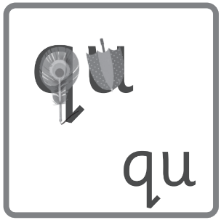 | quill – around the feather and down the pen | quit, quick, quack, liquid, quiz
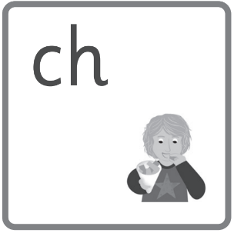 | chew the chunky chips | chop, check, chill, chicken, chin, chug, chip, much, such

Words we are learning to write | Harder to Read and Spell Words
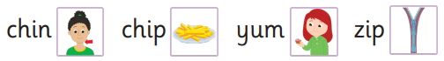 | we, me be

Essential letters and sounds EYFS Phonics Home Learning
Phase 3 - Autumn 2 Week 3
Please support your child to practise and reinforce the phonemes and graphemes we are learning in school.
Sounds we have focused on this week | Mnemonics and Rhymes  (to support letter formation and recall) | Words we are learning to segment and blend
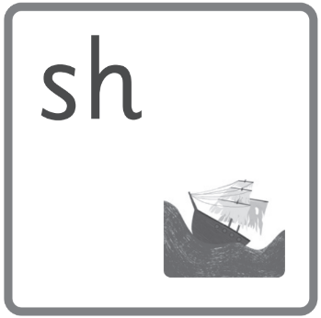 | the shabby ship shook | ship, shop, fish, shed, shell, crash, cash, rush, rash, trash, flash, bash, mash, dash, sash, shock, hush, slapdash
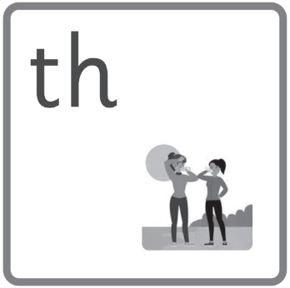 | they were thirsty | them, with, that, this, then  thick, moth, thin
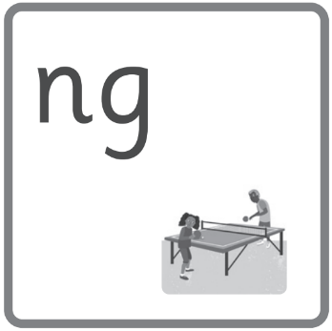 | ping pong | song, long, ring, sing, king, ping, ping-pong, rang, wing, sang, hang, bang, rung, sung, tong, strong, thing
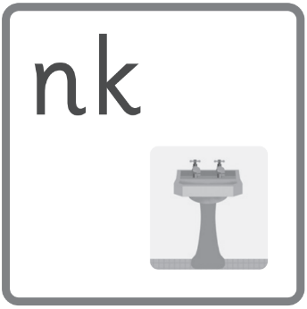 | oooh! a pink sink | think, thank, drink, sink, link, bank, sank, honk

Words we are learning to write | Harder to Read and Spell Words
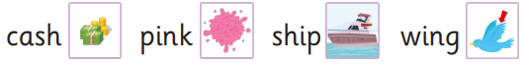 | push

Essential letters and sounds EYFS Phonics Home Learning
Phase 3 - Autumn 2 Week 4
Please support your child to practise and reinforce the phonemes and graphemes we are learning in school.
Sounds we have focused on this week | Mnemonics and Rhymes  (to support letter formation and recall) | Words we are learning to segment and blend
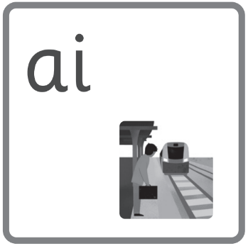 | wait for the train | wait, rain, pain, tail, sail, plain, drain, grain, brain, train, snail, main, hail, aim, maid, stain, strain, nail, wail, bait, fail, jail, pail, quail
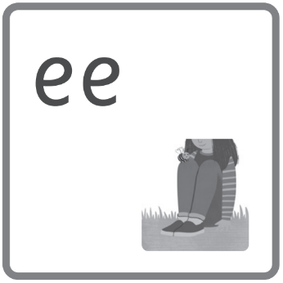 | bee on my knee | tree, see, deep, meet, jeep, keep, peep, sleep, cheep, creep, creek, cheek, sixteen, free, glee, steel, queen, teen, deepest, street, meeting, fleeting, flee, bee, gleeful, seed, weep, weeping, creeping, feed, feeding, speeding, speed, sweep, sweeping, teeth, teething
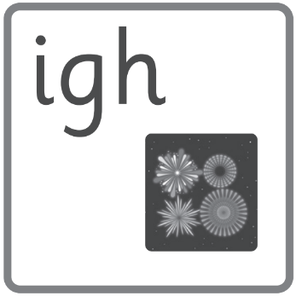 | light up the night | right, flight, fight, tight, sigh, thigh, sunlight, midnight, highlight, spotlight, high, light, lighting, flashlight, lightning, alight, slight, plight, sighing, alighting, might
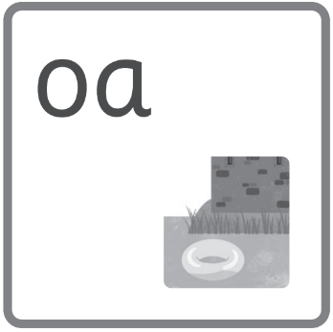 | float on the moat | coat, goat, toast, roast, coast, load, coach, raincoat, oak, float, groan, moat, soap, bloat, toad, soak, loan, throat, roam, foam, gloat, poach, encroach, cockroach, loaf, road, roadblock, oat, oats, oatmilk, stoat, foaming, oath, gloating, toads, croak, croaking

Words we are learning to write | Harder to Read and Spell Words
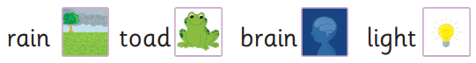 | was, her

Essential letters and sounds EYFS Phonics Home Learning
Phase 3 - Autumn 2 Weeks 5 and 6
This week we have reviewed and revised all of the sounds we have learnt so far and practised reading texts containing these sounds.
Why not practise reading and writing the words below?
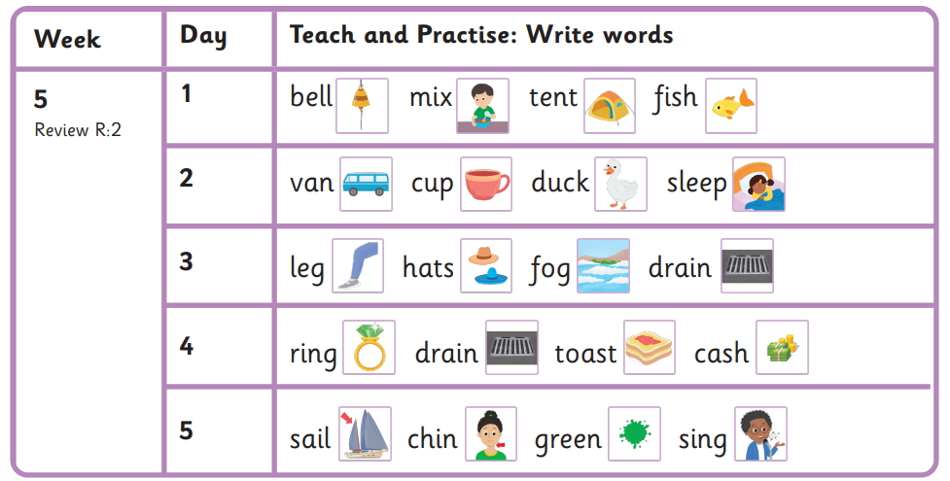
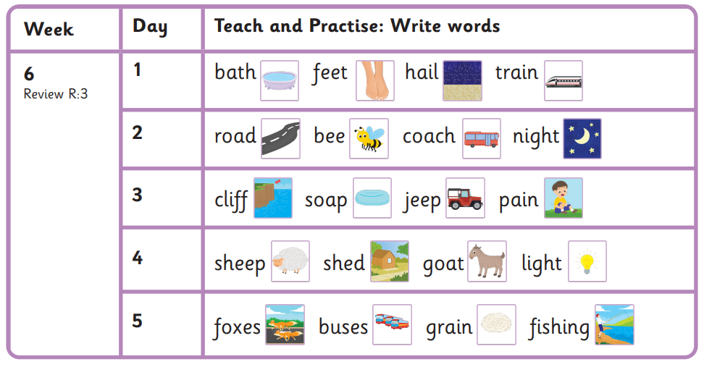

Harder to Read and Spell Words
my, you

