Essential letters and sounds EYFS Phonics Home Learning | 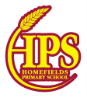
Phase 2 - Autumn 1 Week 2

Please support your child to practise and reinforce the phonemes and graphemes we are learning in school.
Sounds we have focused on this week | Mnemonics and Rhymes  (to support letter formation) | Words we are learning to segment and blend
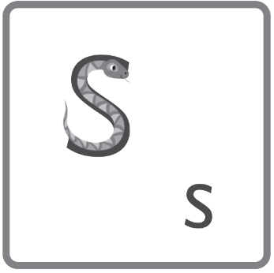 | snake - swerve around the snake  (start at the snake’s head)
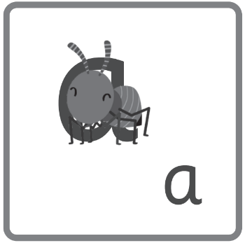 | ant – around the head and down the body
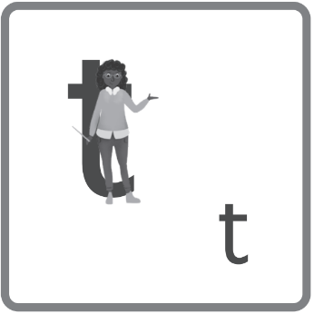 | teacher – down her body and cross her shoulders | sat, at
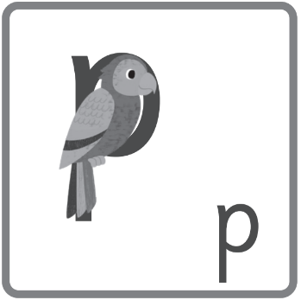 | parrot – down his body and around his face | pat, tap, sap

Words we are learning to write
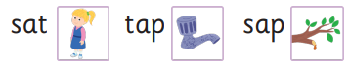

Essential letters and sounds EYFS Phonics Home Learning
Phase 2 - Autumn 1 Week 3
Please support your child to practise and reinforce the phonemes and graphemes we are learning in school.
Sounds we have focused on this week | Mnemonics and Rhymes  (to support letter formation) | Words we are learning to segment and blend
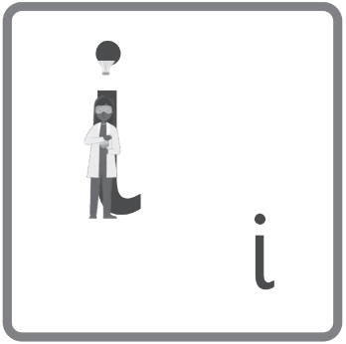 | inventor – down her body, spot her idea | it, pit, sit, sip, pip, tip
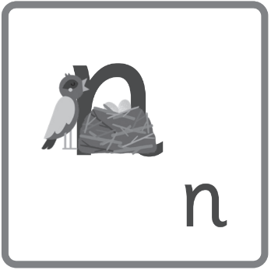 | nest – down the bird and over her nest | an, in, pin, tin, tan, pan, nap, nip
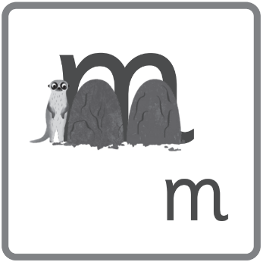 | meerkat – meerkat, mound, mound | map, Pam, mat, man, Sam, Tim
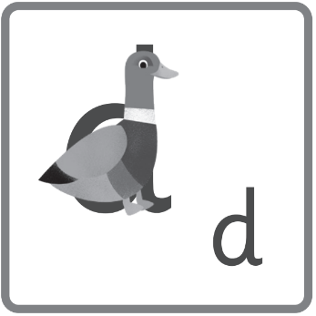 | duck – over his back and around his tail, up his neck and down to his feet | and, dim, did, din, dad, sad, Sid

Words we are learning to write | Harder to Read and Spell Words
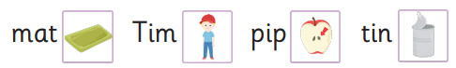 | I, the, no

Essential letters and sounds EYFS Phonics Home Learning
Phase 2 - Autumn 1 Week 4
Please support your child to practise and reinforce the phonemes and graphemes we are learning in school.
Sounds we have focused on this week | Mnemonics and Rhymes  (to support letter formation) | Words we are learning to segment and blend
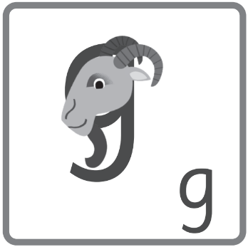 | goat – start at his ear, around the face and down the beard | gap, dig, digs, tag, gas, nag, gig, sag
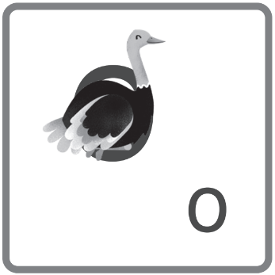 | ostrich – around the ostrich’s body | dog, got, Mog, pop, top, got, on, not, odd
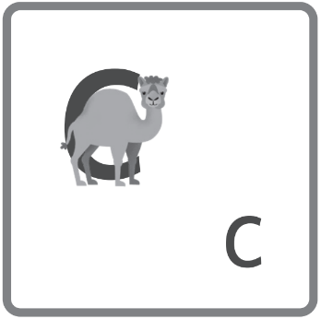 | camel – curl around the camel’s back | cat, cot, can, cap, cod, picnic
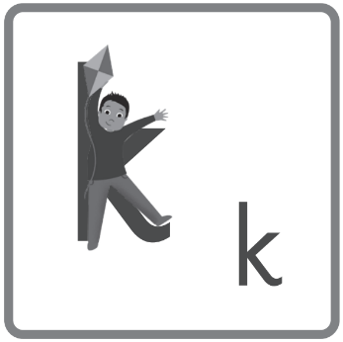 | kid – down the body, up the arm and down the leg | kit, kid, Ken, Kim, kip

Words we are learning to write | Harder to Read and Spell Words
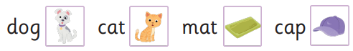 | put, of, is

Essential letters and sounds EYFS Phonics Home Learning
Phase 2 - Autumn 1 Week 5
Please support your child to practise and reinforce the phonemes and graphemes we are learning in school.
Sounds we have focused on this week | Mnemonics and Rhymes  (to support letter formation) | Words we are learning to segment and blend
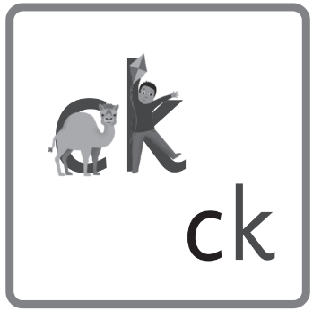 | a camel and a kid – the camel stood by the kid | kick, dock, pack, pick, sock, sack, sick, back
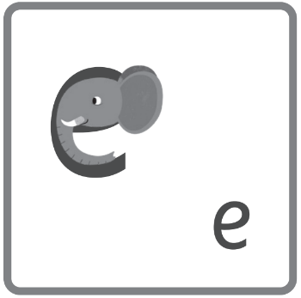 | elephant – around the head and down the trunk | ten, egg, get, met, pet, men, pocket, peg, neck, pen, net, ticket
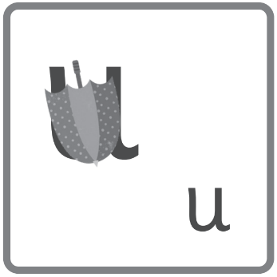 | umbrella – under the umbrella and down to the tip | up, mum, mud, sun, tub, cup, sunset, mug, duck, tuck
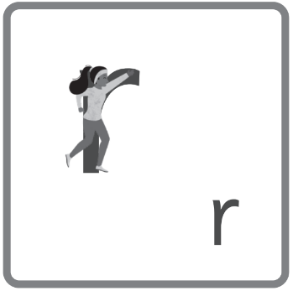 | runner – down her body and up over the arm | rim, rat, rot, rip, rap, rocket, rat, rug, run, ram, *carrot

Words we are learning to write | Harder to Read and Spell Words
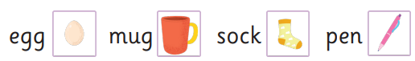 | to, go, into

Essential letters and sounds EYFS Phonics Home Learning
Phase 2 - Autumn 1 Week 6
Please support your child to practise and reinforce the phonemes and graphemes we are learning in school.
Sounds we have focused on this week | Mnemonics and Rhymes  (to support letter formation) | Words we are learning to segment and blend
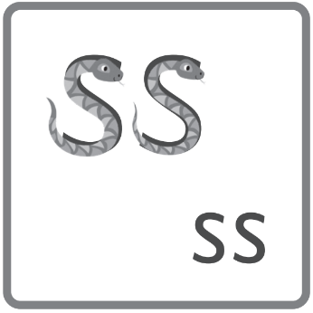 | two snakes – sunbathing snakes | mess, miss, moss, mass, kiss, less, hiss, Tess

Words we are learning to write | Harder to Read and Spell Words
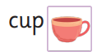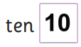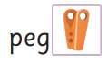 | pull

This week we have reviewed and revised all of the sounds we have learnt so far and practised reading texts containing these sounds.

Essential letters and sounds EYFS Phonics Home Learning
Phase 2 - Autumn 1 Week 7
Please support your child to practise and reinforce the phonemes and graphemes we are learning in school.
Sounds we have focused on this week | Mnemonics and Rhymes  (to support letter formation) | Words we are learning to segment and blend
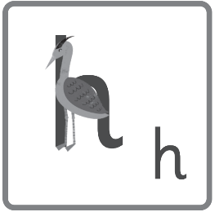 | heron – from his head to his feet, up and over his back | him, hot, hat, hum, hiss, had, hop, hug. sunhat
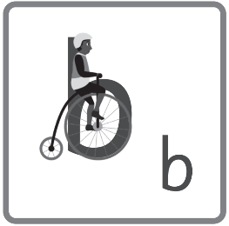 | bike – down the person and around the wheel | bag, bed, big, back, boss, bat, bun, bus, *rabbit
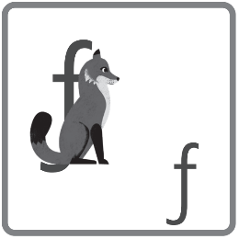  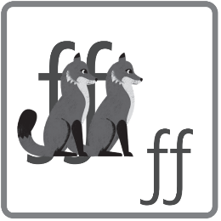 | fox – over the ear, down to the tail and across the jaw  two foxes – two foxes facing forwards | fig, fog, huff, fan, puff, if, off, fun, fuss, cuff, fin
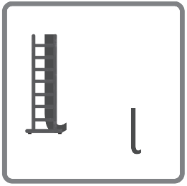  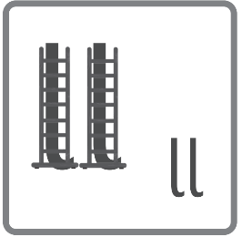 | ladder – down the long ladder  two ladders – ladders in a line | lap, Bill, less, lap, lot, fill, sell, dull, let, lit, doll, laptop, lot, bell, tell, mill, pill, till, will, dill, fell

Words we are learning to write | Harder to Read and Spell Words
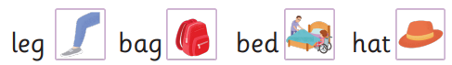 | as, his

