

**Geography**

**To investigate places**

* Collect and analyse statistics and other information in order to draw clear conclusions about locations.
* Identify and describe how the physical features affect the human activity within a location.
* Name and locate some of the countries and cities of the worldand their identifying human and physical characteristics, including hills, mountains, rivers, key topographical features and land-use patterns; andunderstand how some of these aspects have changed over time.
* Name and locate the countries of North and South America and identify their main physical and human characteristics.

**To investigate patterns**

* Identify and describe the geographical significance of latitude, longitude, Equator, Northern Hemisphere, Southern Hemisphere, the Tropics of Cancer and Capricorn, Arctic and Antarctic Circle, and time zones (including day and night).

**To communicate geographically**

Describe and understand key aspects of:

* physical geography, including: climate zones, biomes and vegetation belts, rivers, mountains, volcanoes and earthquakes and the water cycle.
* human geography, including: settlements, land use, economic activity including trade links, and the distribution of natural resources including energy, food, minerals, and water supplies.

**All Aboard the Titanic**

**Skills and Knowledge**

**Year 5&6 – Spring 1 - 2022**

This topic allows children to develop a range of historical and geographical skills through the event if the sinking of Titanic. Through geographical data, primary and secondary sources, personal stories and discussion, children will gain a ‘feel’ for the historical period. They will also examine the inter-related events that led up to the sinking and the aftermath, along with the historical significance and cultural impact today.

**History**

**To investigate and interpret the past**

* Use sources of evidence to deduce information about the past.
* Select suitable sources of evidence, giving reasons for choices.
* Use sources of information to form testable hypotheses about the past.
* Seek out and analyse a wide range of evidence in order to justify claims about the past.
* Understand that no single source of evidence gives the full answer to questions about the past.
* Refine lines of enquiry as appropriate.

**To build an overview of world history**

* Give a broad overview of life in Britain from medieval until the Tudor and Stuarts times.

**To understand chronology**

* Understand the concepts of continuity and change over time, representing them, along with evidence, on a time line.
* Use dates and terms accurately in describing events

**To communicate historically**

* Use appropriate historical vocabulary to communicate, including: dates, time period, era, chronology, continuity, change, century, decade, legacy.
* Use literacy, numeracy and computing skills to an exceptional standard in order to communicate information about the past.
* Use original ways to present information and ideas.



**R.E**

**U2.5 Is it better to express your beliefs in arts and architecture or in charity and generosity?**

**To Know and Understand**

* Describe and make connections between examples of religious creativity (buildings and art).

**To Express and Communicate**

* Show understanding of the value of sacred buildings and art.
* Suggest reasons why some believers see generosity and charity as more important than buildings and art.

**To Gain and Deploy Skills**

* Apply ideas about values and from scriptures to the title question.

**‘Roll up, Roll up!’ Here is a collection of objective we will be covering this term with the children. Each week our newsletter will provide you with more detailed information about your Year 1 or Year 2 child’s learning. It will also provide you with activity suggestions to help support their learning.**

**We cannot wait to begin our Circus topic and start having lots of fun!**

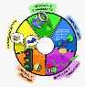

**Computing**

**To Code**

* Set IF conditions for movements. Specify types of rotation giving the number of degrees (motion)
* Change the position of objects between screen layers (send to back, bring to front (looks)
* Upload sounds from file and edit them. Add effects such as fade in and out and control their implementation (sound)
* Combine the use of pens with movement to create interesting effects (draw)
* Set events to control other events by ‘broadcasting’ information as a trigger (events)
* Use IF THEN ELSE conditions to control events or objects (control)
* Use a range of sensing tools (including proximity user inputs, loudness, and mouse position) to control events or actions (sensing)
* Use lists to create a set of variables (variables and lists)

**To Connect**

* Collaborate with others online on site approved and moderated by teachers

**To Communicate**

* Choose the most suitable applications and devices for the purposes of communication
* Use many of the advanced features in order to create high quality, professional or efficient communication

**To Collect**

* Select applications to devise, construct and manipulate data and present it in an effective and professional manner

**Music**

**To Perform**

* Sing or play from memory with confidence.
* Perform solos or as part of an ensemble.
* Sing or play expressively and in tune.
* Perform with controlled breathing (voice) and skilful playing (instrument).

**To Compose**

* Use symbols to represent a composition and use them to help with a performance.
* Create songs with verses and a chorus.
* Create rhythmic patterns with an awareness of timbre and duration.
* Combine a variety of musical devices, including melody, rhythm and chords.
* Thoughtfully select elements for a piece in order to gain a defined effect.
* Convey the relationship between the lyrics and the melody.

**To Transcribe**

* Use the standard musical notation of crotchet, minim and semibreve to indicate how many beats to play.
* Read and create notes on the musical stave.
* Understand the purpose of the treble and bass clefs and use them in transcribing compositions.
* Understand and use the # (sharp) and ♭ (flat) symbols.
* Use and understand simple time signatures.

**To Describe**

* Choose from a wide range of musical vocabulary to accurately describe and appraise music.
* Describe how lyrics often reflect the cultural context of music and have social meaning.

**PSHE** – Citizenship

* To know that if I have a problem, I can call ChildLine on 0800 1111.
* Exploring the impact that bullying might have.
* To know what attributes and skills make a good friend.
* To know what action a bystander can take when they see bullying.
* Identifying ways to resolve conflict through negotiation and compromise.
* To know that a conflict is a disagreement or argument and can occur in friendships.
* To understand the concepts of negotiation and compromise.
* Exploring our positive attributes and being proud of these (self-respect).
* To understand what respect is.
* To understand that everyone deserves respect but respect can be lost.
* To understand that stereotypes can lead to bullying and discrimination.
* Explaining why reducing the use of materials is positive for the environment.
* Discussing how rights and responsibilities link.
* Exploring the right to a freedom of expression.
* Identifying the contribution people make to the community and how this is recognised.
* Developing an understanding of how parliament and Government work.
* Identifying ways people can bring about change in society.
* To know what happens when someone breaks the law.
* To understand the waste hierarchy.
* To know that parliament is made up of the House of Commons, the House of Lords and the Monarch.
* To know that parliament is where MPs debate issues, propose laws, amend existing laws and challenge the government’s work
* To know that a pressure group is a group of people who feel very strongly about an issue and want to see something change.
* Learning about environmental issues relating to food.
* Discussing how education and other human rights protect us.
* Identifying causes which are important to us.
* Discussing how people can influence what happens in parliament.
* Discussing ways to challenge prejudice and discrimination.
* Identifying appropriate ways to share views and ideas with others.
* To know that education is an important human right.
* To know that our food choices can affect the environment.
* To know that the prime minister appoints 'ministers' who have responsibility for different areas, such as healthcare and education.
* To know that prejudice is making assumptions about someone based on certain information.
* To know that discrimination is treating someone differently because of certain factors.



**Online Safety – Self-image and**

**Identity**

* I can explain how my online identity can be different to my offline identity.
* I can describe positive ways for someone to interact with others online and understand how this will positively impact on how others perceive them.
* I can explain that others online can pretend to be someone else, including my friends, and can suggest reasons why they might do this.

**Art**

**Drawing**

* Use a variety of techniques to add interesting effects (e.g. reflections, shadows, direction of sunlight).
* Use a choice of techniques to depict movement, perspective, shadows and reflection.
* Choose a style of drawing suitable for the work (e.g. realistic or impressionistic).
* Use lines to represent movement.

**PE**

**Gymnastics**

* Create complex and well-executed sequences that include a full range of movements including: travelling, balances, swinging, springing, flight, vaults, inversions, rotations, bending, stretching and twisting, gestures, linking skills.
* Hold shapes that are strong, fluent and expressive.
* Include in a sequence set pieces, choosing the most appropriate linking elements.
* Vary speed, direction, level and body rotation during floor performances.
* Practise and refine the gymnastic techniques used in performances (listed above).
* Demonstrate good kinesthetic awareness (placement and alignment of body parts is usually good in well-rehearsed actions).
* Use equipment to vault and to swing (remaining upright)

**Fitness is Fun**

Combine sprinting with low hurdles over 60 metres.

• Choose the best place for running over a variety of distances.

• Throw accurately and refine performance by analysing technique and body shape.

• Show control in take-off and landings when jumping.

• Compete with others and keep track of personal best performances, setting targets for improvement.



**English**

**Writing:**

**Write with purpose**

* Identify the audience for writing.
* Choose the appropriate form of writing using the main features identified in reading.
* Note, develop and research ideas.
* Plan, draft, write, edit and improve.

**Use imaginative description**

* Use the techniques that authors use to create characters, settings and plots.
* Create vivid images by using alliteration, similes, metaphors and personification.
* Interweave descriptions of characters, settings and atmosphere with dialogue.

**Organise writing appropriately**

* Guide the reader by using a range of organisational devices, including a range of connectives.
* Choose effective grammar and punctuation.
* Ensure correct use of tenses throughout a piece of writing.

**Use paragraphs**

* Write paragraphs that give the reader a sense of clarity.
* Write paragraphs that make sense if read alone.
* Write cohesively at length.

**Handwriting**

* Write fluently and legibly with a personal style

**Spelling**

* Use prefixes appropriately.
* Spell some words with silent letters (knight, psalm and solemn).
* Distinguish between homophones and other words that are often confused.
* Use knowledge of morphology and etymology in spelling and understand that some words need to be learned specifically.
* Use dictionaries to check spelling and meaning of words.
* Use the first three or four letters of a word to look up the meaning or spelling of words in a dictionary.
* Use a thesaurus.
* Spell the vast majority of words correctly.

**Analyse writing**

* Use and understand grammatical terminology when discussing writing and reading:

**Year 5**

* relative clause, modal verb, relative pronoun, parenthesis, bracket, dash, determiner, cohesion, ambiguity.

**Year 6**

* active and passive voice, subject and object, hyphen, synonym, colon, semi-colon, bullet points.

**English**

**Spoken Language - Develop a wide and interesting vocabulary:**

* Use adventurous and sophisticated vocabulary.
* Explain the meaning of words, offering alternatives.
* Use a wide range of phrases that include determiners, modifiers and other techniques to add extra interest and clarity.

**Reading:**

* Apply knowledge of root words, prefixes and suffixes.
* Read age-appropriate books with confidence and fluency (including whole novels).
* Recommend books to peers, giving reasons for choices.
* Identify and discuss themes and conventions in and across a wide range of writing.
* Make comparisons within and across books.
* Learn a wide range of poetry by heart.
* Prepare poems and plays to read aloud and to perform, showing understanding through intonation, tone and volume so that the meaning is clear to an audience.
* Check that the book makes sense, discussing understanding and exploring the meaning of words in context.
* Ask questions to improve understanding.
* Draw inferences such as inferring characters’ feelings, thoughts and motives from their actions, and justifying inferences with evidence.
* Predict what might happen from details stated and implied.
* Summarise the main ideas drawn from more than one paragraph, identifying key details that support the main ideas.
* Identify how language, structure and presentation contribute to meaning.
* Discuss and evaluate how authors use language, including figurative language, considering the impact on the reader.
* Retrieve and record information from non-fiction.
* Participate in discussion about books, taking turns and listening and responding to what others say.
* Distinguish between statements of fact and opinion.
* Provide reasoned justifications for views.

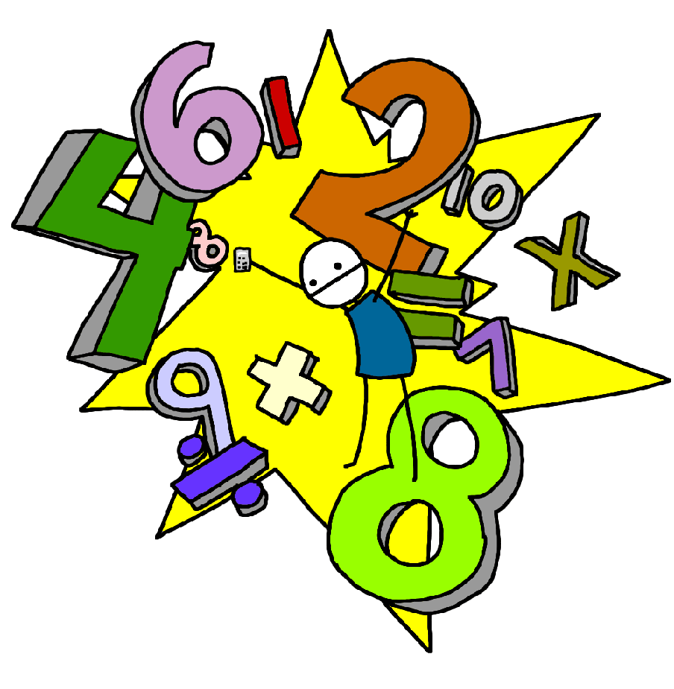

**Maths**

**Year 5**

**Fractions:**

**Recognising Fractions**

* Compare and order fractions whose denominators are all multiples of the same number.

• Compare and order fractions, including fractions > 1.

• Recognise mixed numbers and improper fractions and convert from one form to the other and write mathematical statements > 1 as a mixed number.

**Equivalence**

• Identify, name and write equivalent fractions of a given fraction, represented visually, including tenths and hundredths.

• Use common factors to simplify fractions; use common multiples to express fractions in the same denomination.

• Associate a fraction with division and calculate decimal fraction equivalents.

**Solving Problems**

• Add and subtract fractions with the same denominator and denominators that are multiples of the same number.

• Add and subtract fractions with different denominators and mixed numbers, using the concept of equivalent fractions.

• Multiply proper fractions and mixed numbers by whole numbers, supported by materials and diagrams.

• Multiply simple pairs of proper fractions, writing the answer in its simplest form.

• Divide proper fractions by whole numbers

**Decimals and Percentages:**

*See below for Milestone Statements*

**Year 6**

**Decimals and Percentages:**

* Round decimals with two decimal places to the nearest whole number and to one decimal place.
* Read, write, order and compare numbers with up to three decimal places
* Identify the value of each digit in numbers given to three decimal places.
* Solve problems involving number up to three decimal places.
* Recognise the percent symbol (%) and understand that percent relates to ‘number of parts per hundred’, and write percentages as a fraction with denominator 100, and as a decimal.
* Identify, name and write equivalent fractions of a given fraction, represented visually, including tenths and hundredths.
* Read and write decimal numbers as fractions.
* Recognise and use thousandths and relate them to tenths, hundredths and decimal equivalents.
* Use common factors to simplify fractions; use common multiples to express fractions in the same denomination.
* Associate a fraction with division and calculate decimal fraction equivalents.
* Recall and use equivalences between simple fractions, decimals and percentages, including in different contexts.

**Algebra:**

* Use simple formulae.
* Generate and describe linear number sequences.
* Express missing number problems algebraically.
* Find pairs of numbers that satisfy an equation with two unknowns.
* Enumerate possibilities of combinations of two variables.