

**Geography**

**To investigate places**

* Collect and analyse statistics and other information in order to draw clear conclusions about locations.
* Identify and describe how the physical features affect the human activity within a location.
* Use a range of geographical resources to give detailed descriptions and opinions of the characteristic features of a location.
* Analyse and give views on the effectiveness of different geographical representations of a location.
* Name and locate some of the countries and cities of the worldand their identifying human and physical characteristics, including hills, mountains, rivers, key topographical features and land-use patterns; andunderstand how some of these aspects have changed over time.

**To investigate patterns**

* Understand some of the reasons for geographical similarities and differences between countries.
* Describe how locations around the world are changing and explain some of the reasons for change.
* Describe how countries and geographical regions are interconnected and interdependent.

**To communicate geographically**

Describe and understand key aspects of:

* physical geography, including: climate zones, biomes and vegetation belts, rivers, mountains, volcanoes and earthquakes and the water cycle.
* human geography, including: settlements, land use, economic activity including trade links, and the distribution of natural resources including energy, food, minerals, and water supplies.
* Use the eight points of a compass, four-figure grid references, symbols and a key (that uses standard Ordnance Survey symbols) to communicate knowledge of the United Kingdom and the world.
* Create maps of locations identifying patterns (such as: land use, climate zones, population densities, height of land).

**Peak Adventures - Mountains**

**Skills and Knowledge**

**Year 5&6 – Autumn 2 2022**



This topic allows us to enter into the world of mountains and the many secrets they hold. With a strong focus on geographical skills, children will expand their knowledge of the world while developing atlas and map skills, analysing geographical data and identifying both physical and human patterns.

**R.E**

**If God is everywhere, why go to a place of worship?**

**To understand beliefs and teachings**

* Explain how some teachings and beliefs are shared between religions

**To understand practises and lifestyles**

* Explain the practice and lifestyles involved in belonging to a faith community

**To understand how beliefs are conveyed**

* Explain some of the different ways that individuals show their beliefs

**Reflect**

* Recognise and express feelings about their own identities. Relate these to religious beliefs and teachings.



**Art**

**Develop Ideas**

* Develop and imaginatively extend ideas from starting points throughout the curriculum.
* Use the qualities of materials to enhance ideas.
* Comment on artworks with a fluent grasp of visual language.

**Painting**

* Sketch (lightly) before painting to combine line and colour.
* Create a colour palette based upon colours observed in the natural or built world.
* Use the qualities of watercolour and acrylic paints to create visually interesting pieces.
* Combine colours, tones and tints to enhance the mood of a piece.
* Use brush techniques and the qualities of paint to create texture.
* Develop a personal style of painting, drawing upon ideas from other artists.

**Take Inspiration from the Greats**

* Give details (including own sketches) about the style of some notable artists, artisans and designers.



**Science**

**To understand electrical circuits**

* Associate the brightness of a lamp or the volume of a buzzer with the number and voltage of cells used in the circuit.
* Compare and give reasons for variations in how components function, including the brightness of bulbs, the loudness of buzzers and the on/off position of switches.
* Use recognised symbols when representing a simple circuit in a diagram.

**‘Roll up, Roll up!’ Here is a collection of objective we will be covering this term with the children. Each week our newsletter will provide you with more detailed information about your Year 1 or Year 2 child’s learning. It will also provide you with activity suggestions to help support their learning.**

**We cannot wait to begin our Circus topic and start having lots of fun!**



**PSHE** – Health and Wellbeing

* Developing independence for protecting myself in the sun.
* To understand the risks of sun exposure.
* Considering ways to prevent illness.
* Identifying some actions to take if I am worried about my health or my friends’ health.
* To understand that vaccinations can give us protection against disease.
* To know that changes in the body could be possible signs of illness.
* Understanding the relationship between stress and relaxation.
* Considering calories and food groups to plan healthy meals.
* Developing greater responsibility for ensuring good quality sleep.
* To know that relaxation stretches can help us to relax and de-stress.
* To know that calories are the unit that we use to measure the amount of energy certain foods give us.
* To know that what we do before bed can affect our sleep quality.
* Identifying a range of relaxation strategies and situations in which they would be useful.
* Exploring ways to maintain good habits.
* Setting achievable goals for a healthy lifestyle.
* To understand that a number of factors contribute to my physical health (diet, exercise, rest/relaxation, dental health).
* To know that a habit is a behaviour that we often do without thinking and that we can have good and bad habits.
* Taking responsibility for my own feelings.
* To understand what can cause stress.
* To understand that failure is an important part of success.
* Exploring my personal qualities and how to build on them.
* Developing strategies for being resilient in challenging situations.
* To understand that a number of factors contribute to my mental health (Diet, exercise, rest/relaxation).
* To know the effects technology can have on mental health.

**Music**

**To Perform**

* Sing or play from memory with confidence.
* Perform solos or as part of an ensemble.
* Sing or play expressively and in tune.
* Perform with controlled breathing (voice) and skilful playing (instrument).

**To Compose**

* Use symbols to represent a composition and use them to help with a performance.
* Create songs with verses and a chorus.
* Create rhythmic patterns with an awareness of timbre and duration.
* Thoughtfully select elements for a piece in order to gain a defined effect.
* Use drones and melodic ostinati (based on the pentatonic scale).

**To Transcribe**

* Use the standard musical notation of crotchet, minim and semibreve to indicate how many beats to play.
* Read and create notes on the musical stave.
* Understand the purpose of the treble and bass clefs and use them in transcribing compositions.
* Understand and use the # (sharp) and ♭ (flat) symbols.
* Use and understand simple time signatures.

**To Describe**

* Choose from a wide range of musical vocabulary to accurately describe and appraise music.
* Describe how lyrics often reflect the cultural context of music and have social meaning.

**PE**

**Year 5 - Swimming**

* Swim over 100 metres unaided.
* Use breast stroke, front crawl and back stroke, ensuring that breathing is correct so as not to interrupt the pattern of swimming.
* Swim fluently with controlled strokes.
* Turn efficiently at the end of a length.

**Year 5 and 6 – Games (hockey)**

* Choose and combine techniques in game situations (running, throwing, catching, passing, jumping, etc.).
* Work alone, or with team mates in order to gain points or possession.
* Defend and attack tactically by anticipating the direction of play.
* Choose the most appropriate tactics for a game.
* Uphold the spirit of fair play and respect in all competitive situations.
* Lead others when called upon and act as a good role model within a team.

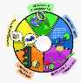

**Computing**

**To Connect**

* Collaborate with others online on site approved and moderated by teachers

**To Communicate**

* Choose the most suitable applications and devices for the purposes of communication
* Use many of the advanced features in order to create high quality, professional or efficient communications

**Online Safety - Privacy and Security**

* I can explain what a strong password is and demonstrate how to create one.
* I can explain how many free apps or services may read and share private information (e.g. friends, contacts, likes, images, videos, voice, messages, geolocation) with others.
* I can explain what app permissions are and can give some examples



**English**

**Writing:**

**Write with purpose**

* Identify the audience for writing.
* Choose the appropriate form of writing using the main features identified in reading.
* Note, develop and research ideas.
* Plan, draft, write, edit and improve.

**Use imaginative description**

* Use the techniques that authors use to create characters, settings and plots.
* Create vivid images by using alliteration, similes, metaphors and personification.
* Interweave descriptions of characters, settings and atmosphere with dialogue.

**Organise writing appropriately**

* Guide the reader by using a range of organisational devices, including a range of connectives.
* Choose effective grammar and punctuation.
* Ensure correct use of tenses throughout a piece of writing.

**Use paragraphs**

* Write paragraphs that give the reader a sense of clarity.
* Write paragraphs that make sense if read alone.
* Write cohesively at length.

**Handwriting**

* Write fluently and legibly with a personal style

**Spelling**

* Use prefixes appropriately.
* Spell some words with silent letters (knight, psalm and solemn).
* Distinguish between homophones and other words that are often confused.
* Use knowledge of morphology and etymology in spelling and understand that some words need to be learned specifically.
* Use dictionaries to check spelling and meaning of words.
* Use the first three or four letters of a word to look up the meaning or spelling of words in a dictionary.
* Use a thesaurus.
* Spell the vast majority of words correctly.

**Analyse writing**

* Use and understand grammatical terminology when discussing writing and reading:

**Year 5**

* relative clause, modal verb, relative pronoun, parenthesis, bracket, dash, determiner, cohesion, ambiguity.

**Year 6**

* active and passive voice, subject and object, hyphen, synonym, colon, semi-colon, bullet points.

**English**

**Spoken Language - Develop a wide and interesting vocabulary:**

* Use adventurous and sophisticated vocabulary.
* Explain the meaning of words, offering alternatives.
* Use a wide range of phrases that include determiners, modifiers and other techniques to add extra interest and clarity.

**Reading:**

* Apply knowledge of root words, prefixes and suffixes.
* Read age-appropriate books with confidence and fluency (including whole novels).
* Recommend books to peers, giving reasons for choices.
* Identify and discuss themes and conventions in and across a wide range of writing.
* Make comparisons within and across books.
* Learn a wide range of poetry by heart.
* Prepare poems and plays to read aloud and to perform, showing understanding through intonation, tone and volume so that the meaning is clear to an audience.
* Check that the book makes sense, discussing understanding and exploring the meaning of words in context.
* Ask questions to improve understanding.
* Draw inferences such as inferring characters’ feelings, thoughts and motives from their actions, and justifying inferences with evidence.
* Predict what might happen from details stated and implied.
* Summarise the main ideas drawn from more than one paragraph, identifying key details that support the main ideas.
* Identify how language, structure and presentation contribute to meaning.
* Discuss and evaluate how authors use language, including figurative language, considering the impact on the reader.
* Retrieve and record information from non-fiction.
* Participate in discussion about books, taking turns and listening and responding to what others say.
* Distinguish between statements of fact and opinion.
* Provide reasoned justifications for views.

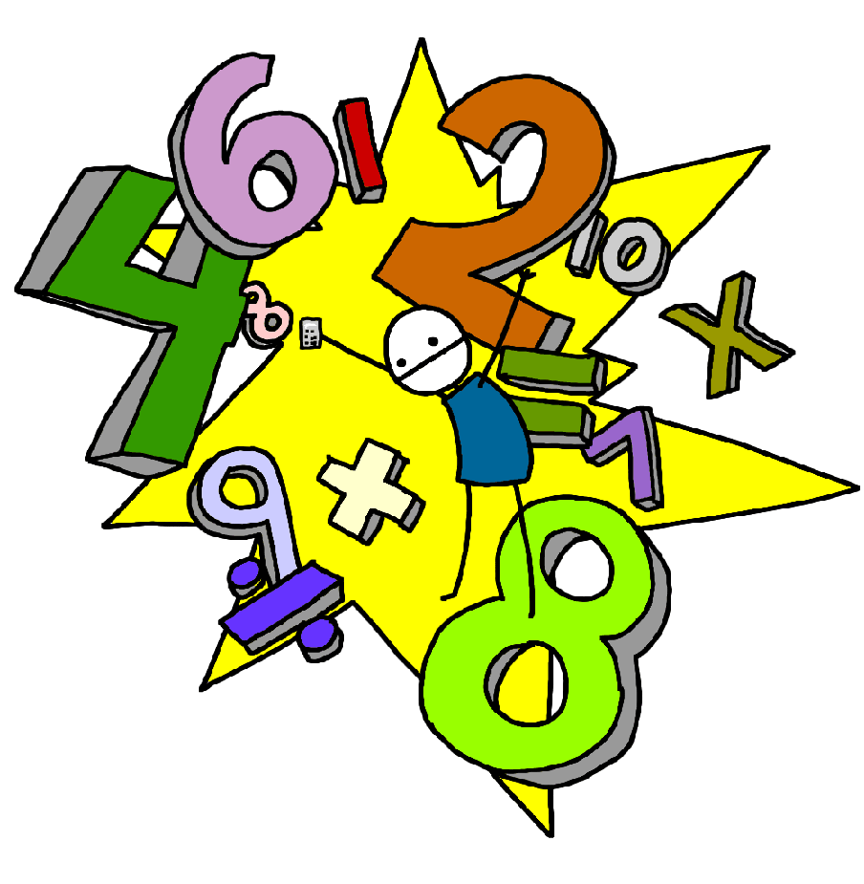

**Maths**

**Year 5**

**Multiply and divide:**

* Solve problems involving addition, subtraction, multiplication and division and a combination of these, including understanding the meaning of the equals sign.

• Solve problems involving multiplication and division, including scaling by simple fractions and problems involving simple rates.

• Use knowledge of the order of operations to carry out calculations involving the four operations.

Multiply multi-digit numbers up to 4 digits by a two-digit whole number using the formal written method of long multiplication.

• Divide numbers up to 4 digits by a two-digit whole number using the formal written method of long division, and interpret remainders as whole number remainders, fractions, or by rounding, as appropriate for the context.

• Divide numbers up to 4 digits by a two-digit number using the formal written method of short division where appropriate, interpreting remainders according to the context.

• Perform mental calculations, including with mixed operations and large numbers.

* Estimate and use inverse operations and rounding to check answers to a calculation.

• Identify common factors, common multiples and prime numbers.

• Establish whether a number up to 100 is prime and recall prime numbers up to 19.

• Multiply and divide whole numbers and those involving decimals by 10, 100 and 1000.

• Recognise and use square numbers and cube numbers, and the notation for squared (2) and cubed (3).

• Solve problems involving multiplication and division including using knowledge of factors and multiples, squares and cubes.

**Area and perimeter –**

* Measure and calculate the perimeter of a composite rectilinear shape in cm and m.
* Calculate and compare the area of rectangles (including squares), and including standard units, square cm and square metres and estimate the area of irregular shapes.

**Year 6**

**Fractions:**

**Recognising Fractions**

* Compare and order fractions whose denominators are all multiples of the same number.

• Compare and order fractions, including fractions > 1.

• Recognise mixed numbers and improper fractions and convert from one form to the other and write mathematical statements > 1 as a mixed number.

**Equivalence**

• Identify, name and write equivalent fractions of a given fraction, represented visually, including tenths and hundredths.

• Use common factors to simplify fractions; use common multiples to express fractions in the same denomination.

• Associate a fraction with division and calculate decimal fraction equivalents.

**Solving Problems**

• Add and subtract fractions with the same denominator and denominators that are multiples of the same number.

• Add and subtract fractions with different denominators and mixed numbers, using the concept of equivalent fractions.

• Multiply proper fractions and mixed numbers by whole numbers, supported by materials and diagrams.

• Multiply simple pairs of proper fractions, writing the answer in its simplest form.

• Divide proper fractions by whole numbers

**Geometry**

 Identify, describe and represent the position of a shape following a reflection or translation, using the appropriate language, and know that the shape has not changed.

• Describe positions on the full coordinate grid. (all four quadrants)

• Draw and translate simple shapes on the coordinate plane, and reflect them in the axes.