**Science** 

**To Investigate Living Things**

* Describe how living things are classified into broad groups according to common observable characteristics.

**To Understand Evolution and Inheritance**

* Recognise that living things produce offspring of the same kind, but normally offspring vary and are not identical to their parents.

**Working Scientifically**

* Use sources of evidence to deduce information about the past.
* Plan enquiries, including recognising and controlling variables where necessary.
* Use appropriate techniques, apparatus, and materials during fieldwork and laboratory work.
* Take measurements, using a range of scientific equipment, with increasing accuracy and precision.
* Record data and results of increasing complexity using scientific diagrams and labels, classification keys, tables, bar and line graphs, and models.
* Report findings from enquiries, including oral and written explanations of results, explanations involving causal relationships, and conclusions.
* Present findings in written form, displays and other presentations.
* Use test results to make predictions to set up further comparative and fair tests.
* Use simple models to describe scientific ideas, identifying scientific evidence that has been used to support or refute ideas or arguments.

**Microscopic Monsters (Micro-Organisms)**

**Skills and Knowledge**

**Year 5&6 – Spring 2 - 2023**

This topic allows children to develop a range of scientific inquiry skills through the study of micro-organisms. Investigations involving mould, decay and food preservation will develop the children knowledge and scientific skills. They will learn about famous scientists who invented vaccines and the impact this has had on the world. Children will also learn about the three main types of micro-organism: bacteria, virus and fungi.

**History**

**To investigate and interpret the past**

* Use sources of evidence to deduce information about the past.

**To understand chronology**

* Describe the main changes in a period of history (using terms such as: social, religious, political, technological and cultural).
* Identify periods of rapid change in history and contrast them with times of relatively little change.

**R.E**

**U2.5 Is it better to express your beliefs in arts and architecture or in charity and generosity?**

**To Know and Understand**

* Describe and make connections between examples of religious creativity (buildings and art).

**To Express and Communicate**

* Show understanding of the value of sacred buildings and art.
* Suggest reasons why some believers see generosity and charity as more important than buildings and art.

**To Gain and Deploy Skills**

* Apply ideas about values and from scriptures to the title question.



**DT – Bread Making**

* Understand the importance of correct storage and handling of ingredients (using knowledge of micro-organisms).
* Measure accurately and calculate ratios of ingredients to scale up or down from a recipe.
* Demonstrate a range of baking and cooking techniques.
* Create and refine recipes, including ingredients, methods, cooking times and temperatures.

**‘Roll up, Roll up!’ Here is a collection of objective we will be covering this term with the children. Each week our newsletter will provide you with more detailed information about your Year 1 or Year 2 child’s learning. It will also provide you with activity suggestions to help support their learning.**

**We cannot wait to begin our Circus topic and start having lots of fun!**

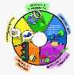

**PE**

**OAA**

* Select appropriate equipment for outdoor and adventurous activity.
* Identify possible risks and ways to manage them, asking for and listening carefully to expert advice.
* Embrace both leadership and team roles and gain the commitment and respect of a team.
* Empathise with others and offer support without being asked. Seek support from the team and the experts if in any doubt.
* Remain positive even in the most challenging circumstances, rallying others if need be.
* Use a range of devices in order to orientate themselves.
* Quickly assess changing conditions and adapt plans to ensure safety comes first.

**Games - Netball**

* Choose and combine techniques in game situations (running, throwing, catching, passing, jumping, etc.).
* Work alone, or with team mates in order to gain points or possession.
* Defend and attack tactically by anticipating the direction of play.
* Choose the most appropriate tactics for a game.
* Uphold the spirit of fair play and respect in all competitive situations.
* Lead others when called upon and act as a good role model within a team.

**Online Safety – Self-image and**

**Identity**

* I can identify ways that I can put information on the internet.
* I can recognise that information can stay online and could be copied.
* I can describe what information I should not put online without asking a trusted adult first.

**Art**

**To Develop Ideas**

* Develop and imaginatively extend ideas from starting points throughout the curriculum.
* Collect information, sketches and resources and present ideas imaginatively in a sketch book.
* Use the qualities of materials to enhance ideas.
* Spot the potential in unexpected results as work progresses.
* Comment on artworks with a fluent grasp of visual language.

**Print**

* Build up layers of colours.
* Create an accurate pattern, showing fine detail.
* Use a range of visual elements to reflect the purpose of the work.

**PSHE** – Economic Wellbeing

* To know that if I have a problem, I can call ChildLine on 0800 1111.
* Discussing risks associated with money.
* Making a budget based on priorities.
* Discussing the role of money in selecting a job.
* Discussing how income can change and the feelings associated with this.
* To know that when money is borrowed it needs to be paid back, usually with interest.
* . To know that it is important to prioritise spending.
* . To know that income is the amount of money received and expenditure is the amount of money spent.
* To know some ways that people lose money
* Recognising differences in how people deal with money and the role of emotions in this.
* Discussing some risks associated with gambling.
* Identifying jobs which might be suitable for them.
* To understand that there are certain rules to follow to keep money safe in bank accounts.
* To know that gambling is a risk where money, or something else, is swapped in the hope of winning something better or more money.
* To understand that different jobs have different routes into them.
* To understand that people change jobs for a number of reasons.
* To know that banks and organisations such as Citizens’ Advice can help with money-related problems.

**Computing**

**To Connect**

* Collaborate with others online on site approved and moderated by teachers.

**To Communicate**

* Choose the most suitable applications and devices for the purposes of communication.
* Use many of the advanced features in order to create high quality, professional or efficient communication.

**Music – ‘You’ve Got a Friend’ – Carole King**

**To Perform**

* Sing or play from memory with confidence.
* Perform solos or as part of an ensemble.
* Sing or play expressively and in tune.
* Perform with controlled breathing (voice) and skilful playing (instrument).

**To Compose**

* Use symbols to represent a composition and use them to help with a performance.
* Create songs with verses and a chorus.
* Create rhythmic patterns with an awareness of timbre and duration.
* Combine a variety of musical devices, including melody, rhythm and chords.
* Thoughtfully select elements for a piece in order to gain a defined effect.
* Convey the relationship between the lyrics and the melody.

**To Transcribe**

* Use the standard musical notation of crotchet, minim and semibreve to indicate how many beats to play.
* Read and create notes on the musical stave.
* Understand the purpose of the treble and bass clefs and use them in transcribing compositions.
* Understand and use the # (sharp) and ♭ (flat) symbols.
* Use and understand simple time signatures.

**To Describe**

* Choose from a wide range of musical vocabulary to accurately describe and appraise music.
* Describe how lyrics often reflect the cultural context of music and have social meaning.



**English**

**Writing:**

**Write with purpose**

* Identify the audience for writing.
* Choose the appropriate form of writing using the main features identified in reading.
* Note, develop and research ideas.
* Plan, draft, write, edit and improve.

**Use imaginative description**

* Use the techniques that authors use to create characters, settings and plots.
* Create vivid images by using alliteration, similes, metaphors and personification.
* Interweave descriptions of characters, settings and atmosphere with dialogue.

**Organise writing appropriately**

* Guide the reader by using a range of organisational devices, including a range of connectives.
* Choose effective grammar and punctuation.
* Ensure correct use of tenses throughout a piece of writing.

**Use paragraphs**

* Write paragraphs that give the reader a sense of clarity.
* Write paragraphs that make sense if read alone.
* Write cohesively at length.

**Handwriting**

* Write fluently and legibly with a personal style

**Spelling**

* Use prefixes appropriately.
* Spell some words with silent letters (knight, psalm and solemn).
* Distinguish between homophones and other words that are often confused.
* Use knowledge of morphology and etymology in spelling and understand that some words need to be learned specifically.
* Use dictionaries to check spelling and meaning of words.
* Use the first three or four letters of a word to look up the meaning or spelling of words in a dictionary.
* Use a thesaurus.
* Spell the vast majority of words correctly.

**Analyse writing**

* Use and understand grammatical terminology when discussing writing and reading:

**Year 5**

* relative clause, modal verb, relative pronoun, parenthesis, bracket, dash, determiner, cohesion, ambiguity.

**Year 6**

* active and passive voice, subject and object, hyphen, synonym, colon, semi-colon, bullet points.

**English**

**Spoken Language - Develop a wide and interesting vocabulary:**

* Use adventurous and sophisticated vocabulary.
* Explain the meaning of words, offering alternatives.
* Use a wide range of phrases that include determiners, modifiers and other techniques to add extra interest and clarity.

**Reading:**

* Apply knowledge of root words, prefixes and suffixes.
* Read age-appropriate books with confidence and fluency (including whole novels).
* Recommend books to peers, giving reasons for choices.
* Identify and discuss themes and conventions in and across a wide range of writing.
* Make comparisons within and across books.
* Learn a wide range of poetry by heart.
* Prepare poems and plays to read aloud and to perform, showing understanding through intonation, tone and volume so that the meaning is clear to an audience.
* Check that the book makes sense, discussing understanding and exploring the meaning of words in context.
* Ask questions to improve understanding.
* Draw inferences such as inferring characters’ feelings, thoughts and motives from their actions, and justifying inferences with evidence.
* Predict what might happen from details stated and implied.
* Summarise the main ideas drawn from more than one paragraph, identifying key details that support the main ideas.
* Identify how language, structure and presentation contribute to meaning.
* Discuss and evaluate how authors use language, including figurative language, considering the impact on the reader.
* Retrieve and record information from non-fiction.
* Participate in discussion about books, taking turns and listening and responding to what others say.
* Distinguish between statements of fact and opinion.
* Provide reasoned justifications for views.

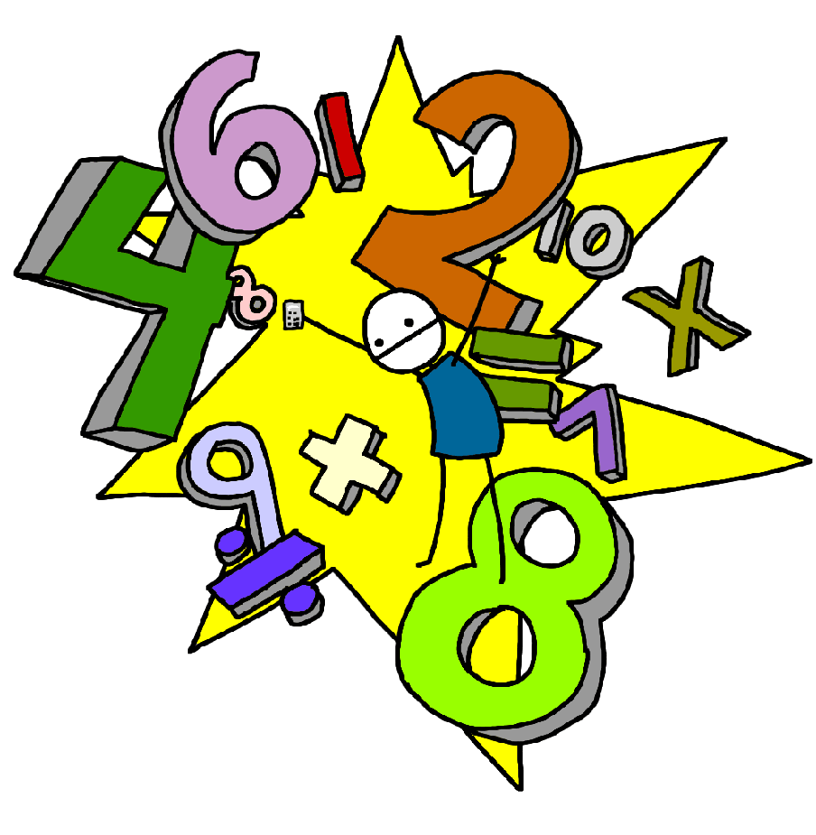

**Maths**

**Year 5 and 6**

**Fractions:**

**Solving Problems**

* Add and subtract fractions with the same denominator and denominators that are multiples of the same number.
* Add and subtract fractions with different denominators and mixed numbers, using the concept of equivalent fractions.
* Multiply proper fractions and mixed numbers by whole numbers, supported by materials and diagrams.
* Multiply simple pairs of proper fractions, writing the answer in its simplest form.
* Divide proper fractions by whole numbers

**Decimals and Percentages:**

* Round decimals with two decimal places to the nearest whole number and to one decimal place.
* Read, write, order and compare numbers with up to three decimal places
* Identify the value of each digit in numbers given to three decimal places.
* Solve problems involving number up to three decimal places.
* Recognise the percent symbol (%) and understand that percent relates to ‘number of parts per hundred’, and write percentages as a fraction with denominator 100, and as a decimal.
* Identify, name and write equivalent fractions of a given fraction, represented visually, including tenths and hundredths.
* Read and write decimal numbers as fractions.
* Recognise and use thousandths and relate them to tenths, hundredths and decimal equivalents.
* Use common factors to simplify fractions; use common multiples to express fractions in the same denomination.
* Associate a fraction with division and calculate decimal fraction equivalents.
* Recall and use equivalences between simple fractions, decimals and percentages, including in different contexts.

**Measurement – Converting Units:**

* Convert between different units of metric measure.
* Understand and use approximate equivalences between metric units and common imperial units such as inches, pounds and pints.
* Estimate volume and capacity.
* Solve problems involving converting between units of time.
* Use all four operations to solve problems involving measure (for example, length, mass, volume, money) using decimal notation, including scaling.
* Solve problems involving the calculation and conversion of units of measure, using decimal notation up to three decimal places where appropriate.
* Use, read, write and convert between standard units, converting measurements of length, mass, volume and time from a smaller unit of measure to a larger unit, and vice versa, using decimal notation up to three decimal places.
* Convert between miles and kilometres.

**Year 6**

**Ratio and proportion**

* Solve problems involving the relative sizes of two quantities where missing values can be found by using integer multiplication and division facts.
* Solve problems involving the calculation of percentages and the use of percentages for comparison.
* Solve problems involving similar shapes where the scale factor is known or can be found.
* Solve problems involving unequal sharing and grouping using knowledge of fractions and multiples.